

**Linux for Devices**

**Lab File**

|  |
| --- |
| Subject Code: CSE438 |

**Submitted By:                                                                          Submitted To:**

Medha Singh                                                                             Dr. Vibha Nehra

A2305218271

7 CSE 4 Y



**AMITY SCHOOL OF ENGINEERING AND TECHNOLOGY**

**AMITY UNIVERSITY CAMPUS, SECTOR-125, NOIDA-201303**

**INDEX**

|  |  |  |  |  |  |
| --- | --- | --- | --- | --- | --- |
| S.No. | Title | Page No. | Date of Allotment | Date of Submission | Signature |
| 1 | Installation of Linux Operating System | 3 | 20.07.2021 | 21.07.2021 |  |
| 2 | Study of Unix/Linux general purpose utility command list obtained from (man, who, cat, cd, cp, ps, ls, mv, rm, mkdir, rmdir, echo, more, date, time, kill, history, chmod, chown, id, pwd, cal, free, shutdown) commands. | 22 | 27.07.2021 | 25.08.2021 |  |
| 3 | To perform various operation on VI Editor | 32 | 03.08.2021 | 25.08.2021 |  |
| 4 | Implementation of simple calculator | 43 | 10.08.2021 | 24.08.2021 |  |
| 5 | Implementation of Docker on Linux Operating System | 47 | 17.08.2021 | 17.08.2021 |  |
| 6 | 1. Shell script program to check whether given file is a directory or not 2. Shell script program to count number of files in a Directory. 3. Shell script program to copy contents of one file to another. 4. Create directory, write contents on that and Copy to a suitable location in your home directory. | 62 | 24.07.2021 | 24.08.2021 |  |
| 7 | 1. Use a pipeline and command substitution to set the length of a line in file to a variable 2. Write a program using sed command to print duplicated lines of Input. | 67 | 31.08.2021 | 31.08.2021 |  |
| 8 | 1. Write a program to illustrate the implementation of integer comparison 2. Write a program to illustrate the implementation of string comparison 3. Write a program to illustrate the implementation of logical operations 4. Write a program to illustrate the implementation of file operations 5. Write a program to illustrate the implementation of conditional control structures 6. Write a program to illustrate the implementation of loop control structures | 71 | 07.09.2021 | 09.09.2021 |  |
| 9 | Write a program for Simple Password Manager Application in Linux | 85 | 21.09.2021 | 21.09.2021 |  |
| 10 | 1. Write a shell script to print a number in reverse order 2. Find the sum of all numbers in a file in Linux 3. Write a shell script to find out the unique words in a file and also count the occurrence of each of these words. 4. Write a shell script to validate password strength. Here are a few assumptions for the password string. Length – minimum of 8 characters, contain both alphabet and number, Include both the small and capital case letters. 5. Write a shell script to delete the lines containing a word <dd> if it appears between the 5th and 7th position? 6. Write a shell script to delete the lines containing a word <dd> if it appears between the 5th and 7th position? | 91 | 28.09.2021 | 30.09.2021 |  |
| 11 | Design and develop a “Birthday Reminder” that can automatically send birthday wishes with a personalized message via email. | 103 | 05.10.2021 | 05.10.2021 |  |
| 12 | Implementation of NIC bonding and Team | 112 | 12.10.2021 | 12.10.2021 |  |
| 13 | Configure NFS Server and Client in Linux | 134 | 19.10.2021 | 19.10.2021 |  |

LAB 1

AIM: Installation of Linux Operating System

THEORY:

Linux is an open-source, secure, complete Operating System which has great advantages over MAC and Windows Operating System. There is no requirement for antivirus programs in Linux OS. The software updates are faster, we can customize the operating system according to our preferences, we also don’t need to spend a huge amount to purchase this OS, Linux ensures privacy of user’s data, it provides high performance in various networks and substations, it is flexible with reference to installing only the components we require. Moreover, Linux provides effective performance even when hard disc space is almost full. We can also run multiple desktops on Linux.

PROCEDURE:

INSTALLING VIRTUAL MACHINE: ORACLE VIRTUAL BOX: DOWNLOAD AND INSTALLATION

Step 1: Search for Oracle VM VirtualBox on Google.

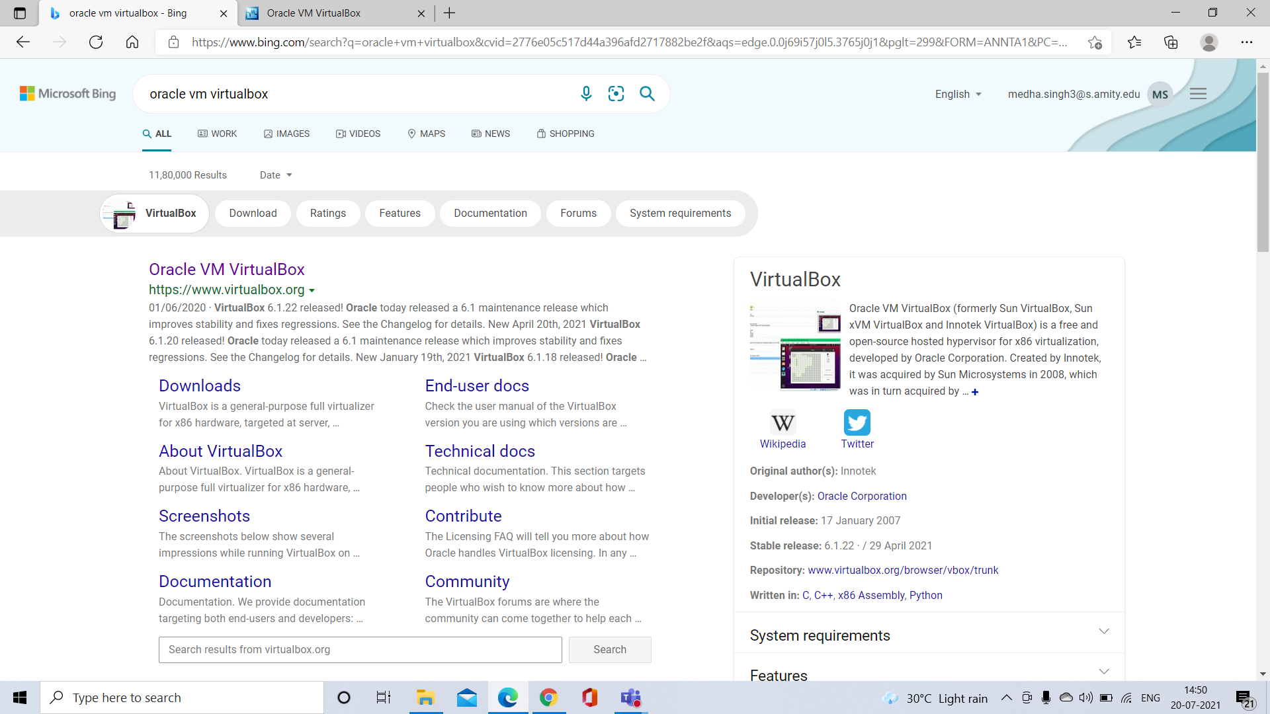

Step 2: Click on the link <https://www.virtualbox.org>

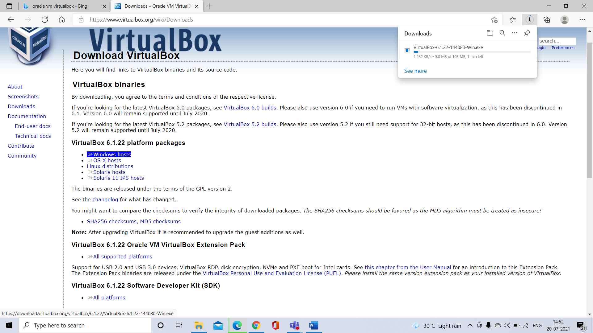

Step 3: Click on Windows Host Link.

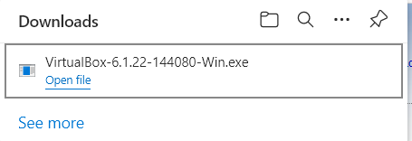

Step 4: After the download completes, start the Oracle VM VirtualBox 6.1.22 Setup and click Next.

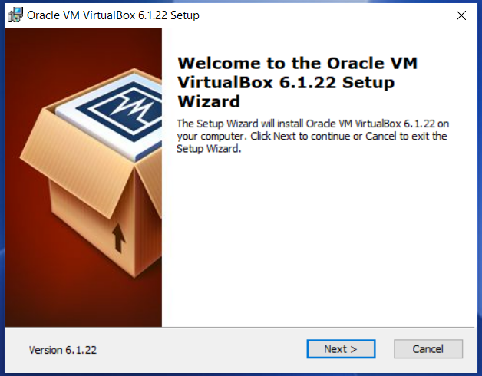

Step 5: Click on Next.

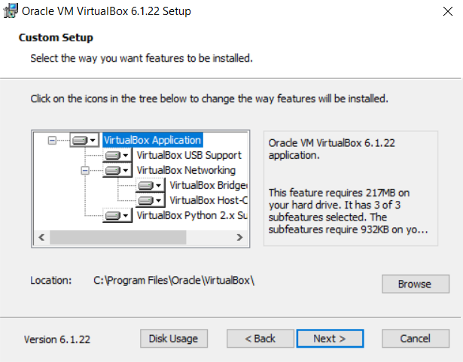

Step 6: Click on Yes

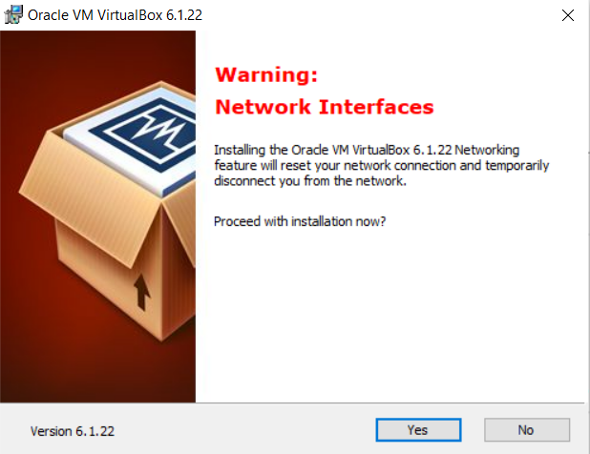

Step 7: Click Install.

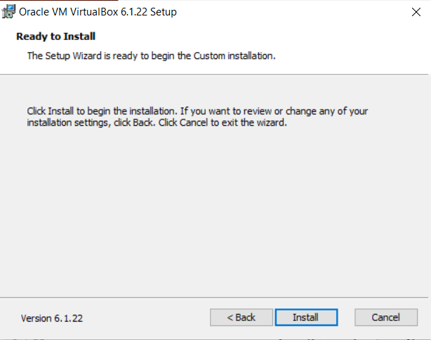

Step 8: Click on Install

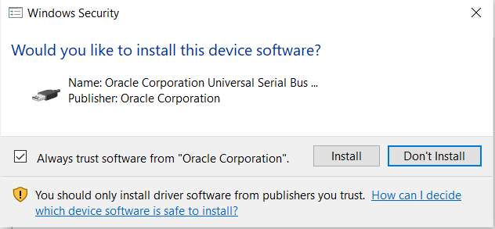

Step 9: Wait for the installation to complete.

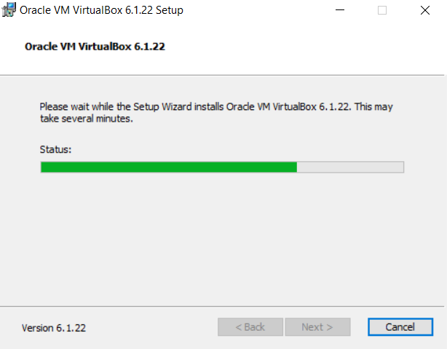

Step 10: Click on Finish.

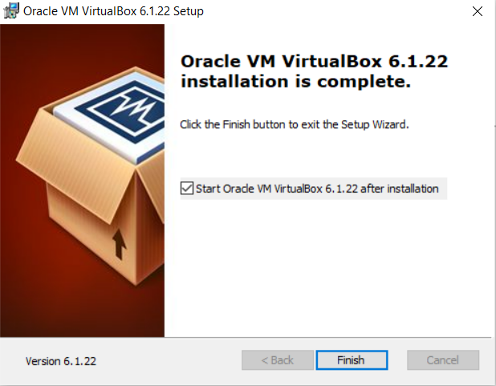

Step 11: Open Virtual Box and click on New

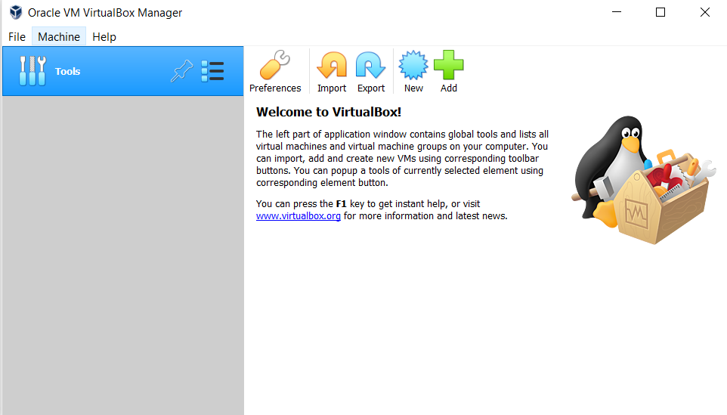

Step 12: Enter Name.

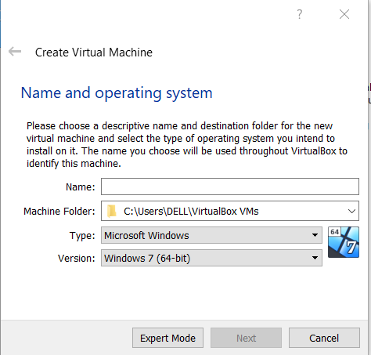

Step 13: Click on Next.

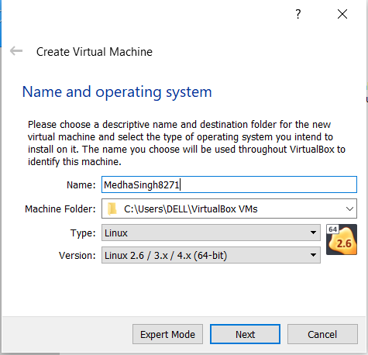

Step 14: Allocate memory size

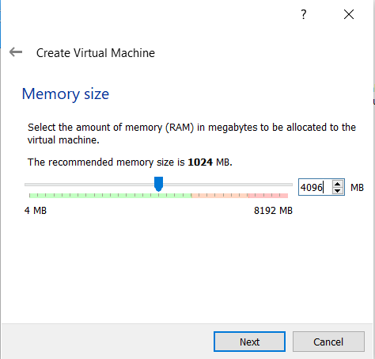

Step 15: Choose VDI and click on Next

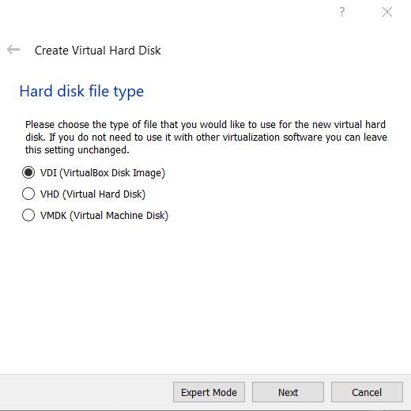

Step 16: Select Dynamically allocated and click on Next

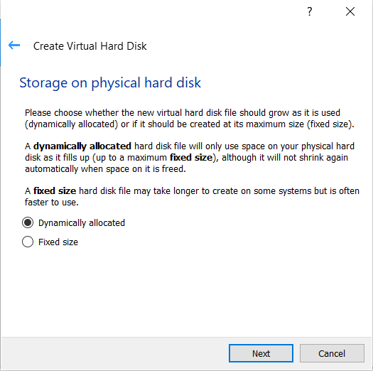

Step 17: Choose File Location and Size

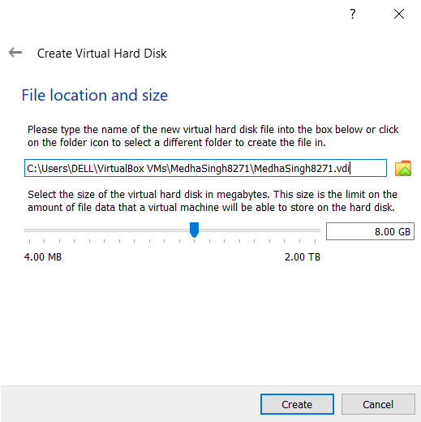

Step 18: The screen must now look like this:

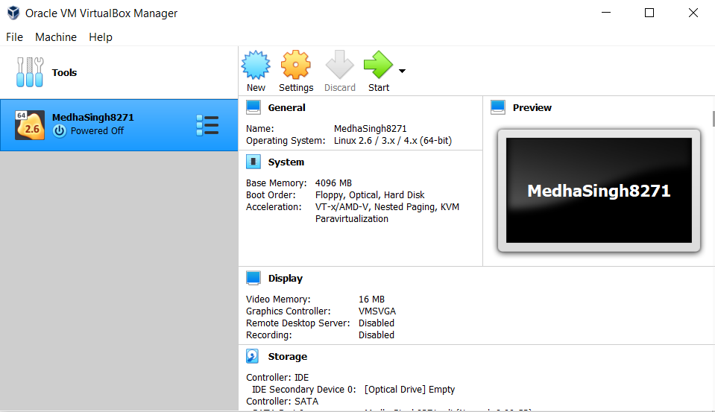

Step 19: Search ubuntu on Google and click on <https://ubuntu.com>

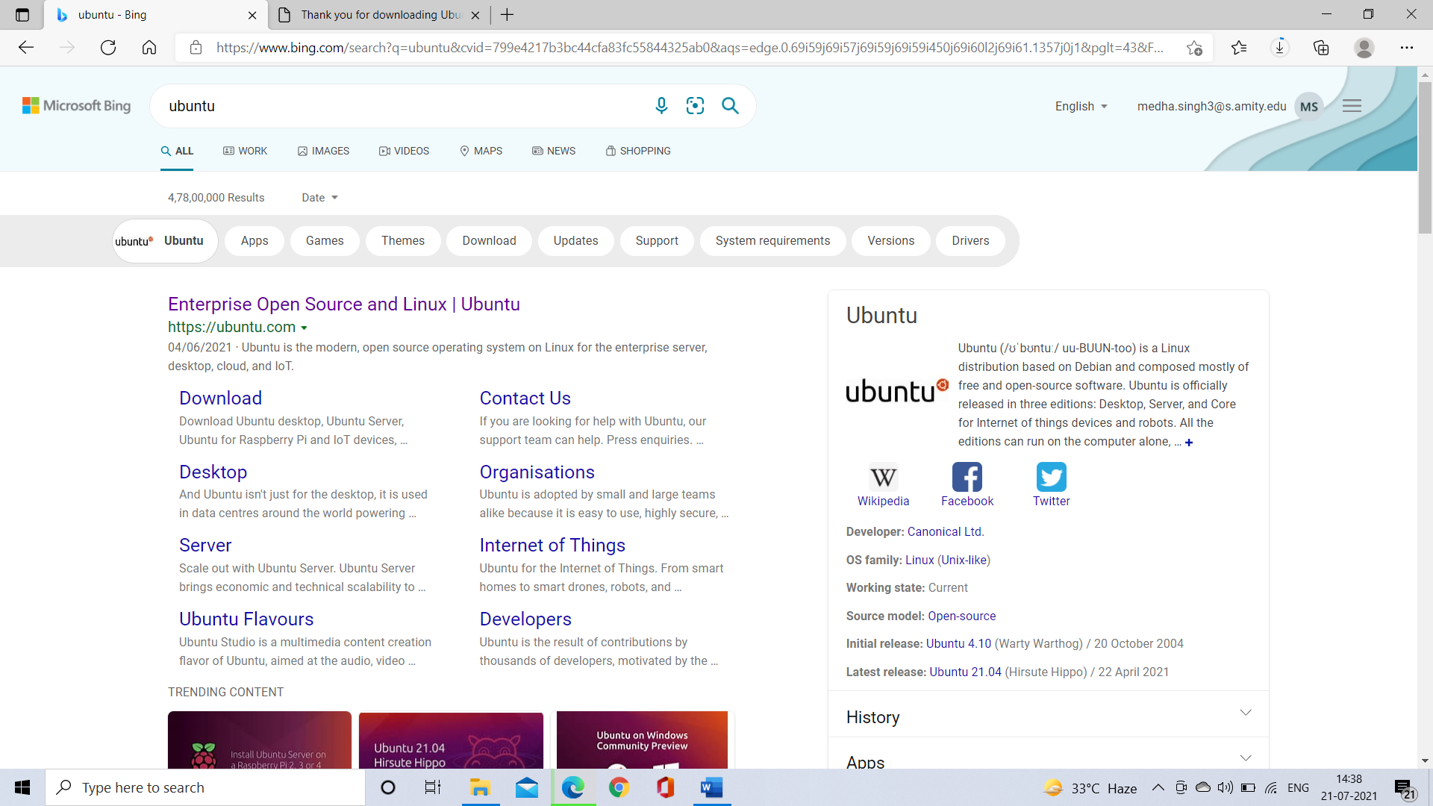

Step 20: Go to Download Section and select Ubuntu Desktop.

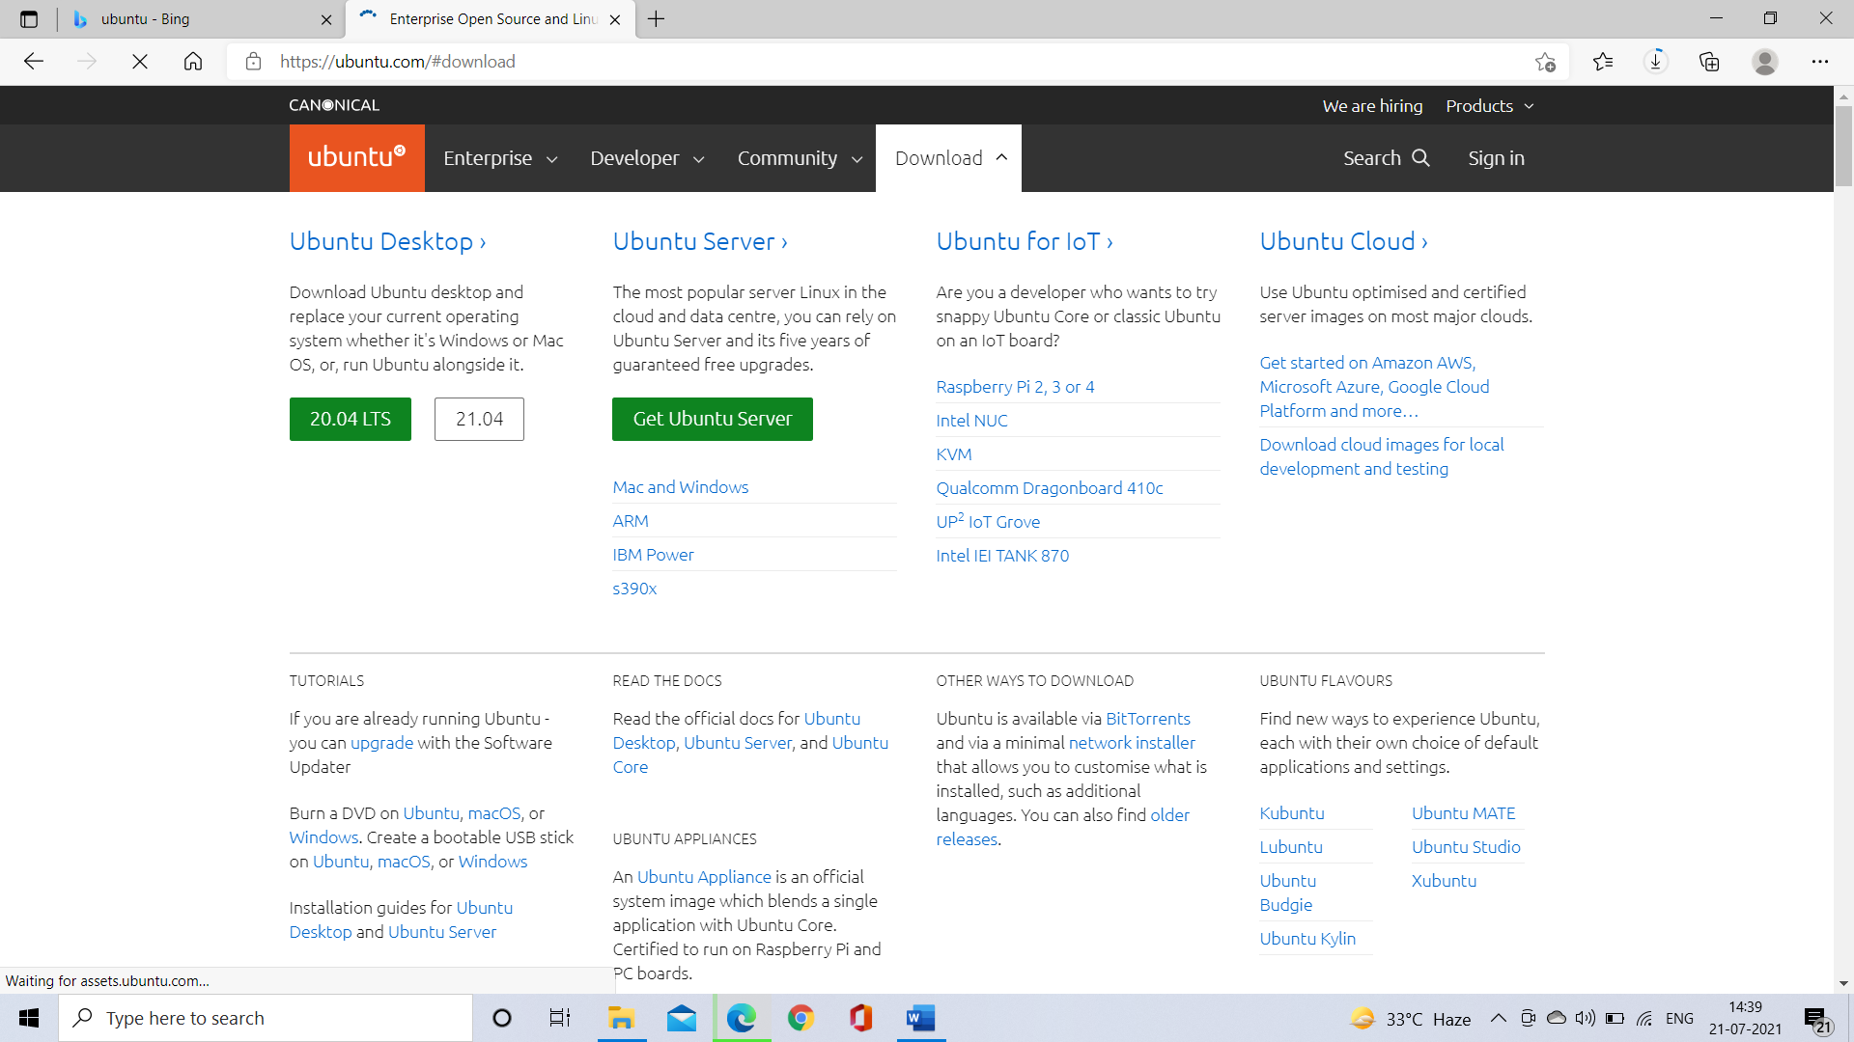

Step 21: Ubuntu Desktop will start downloading. Wait for the download to complete.

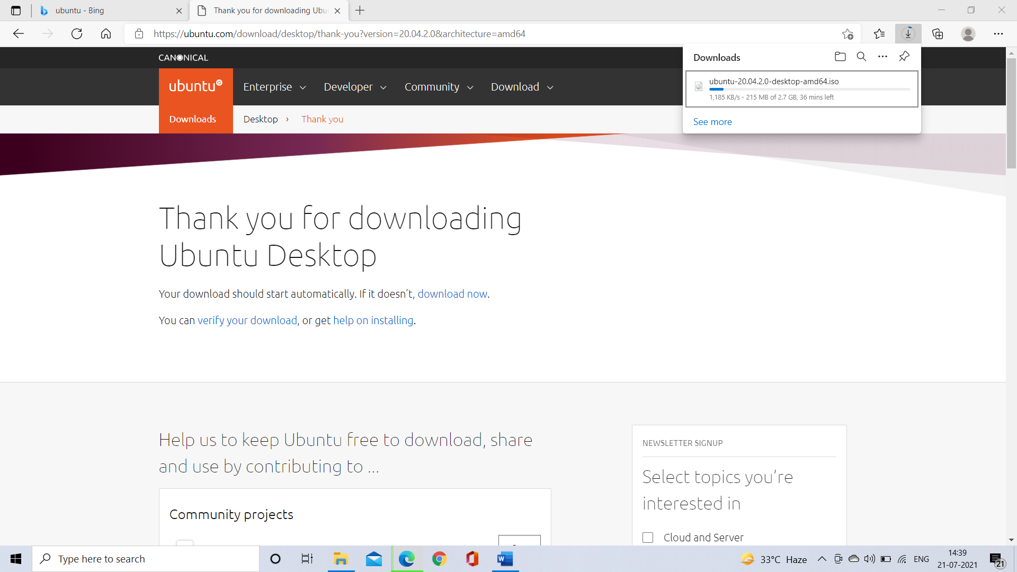

Step 22: Open Oracle VM VirtualBox and click on Start. Click on add and choose the .iso file just downloaded and click on Choose.

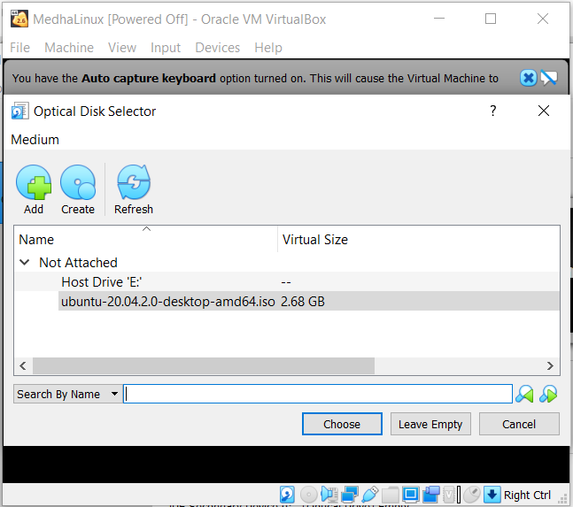

Step 23: Click on Start.

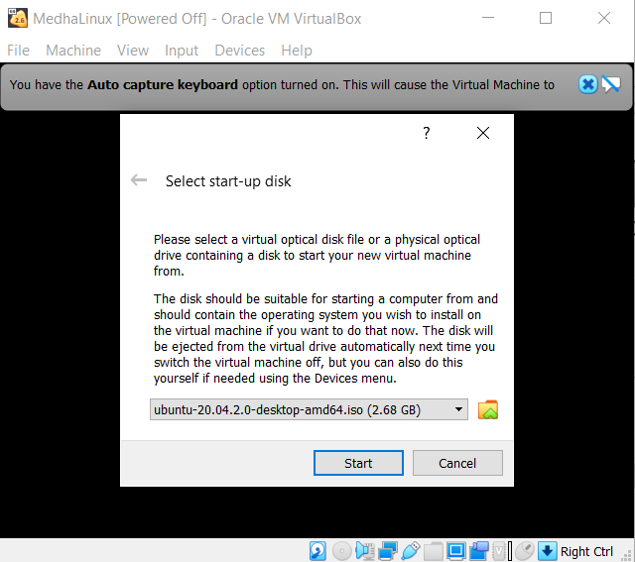

Step 24: Your screen must look like this.

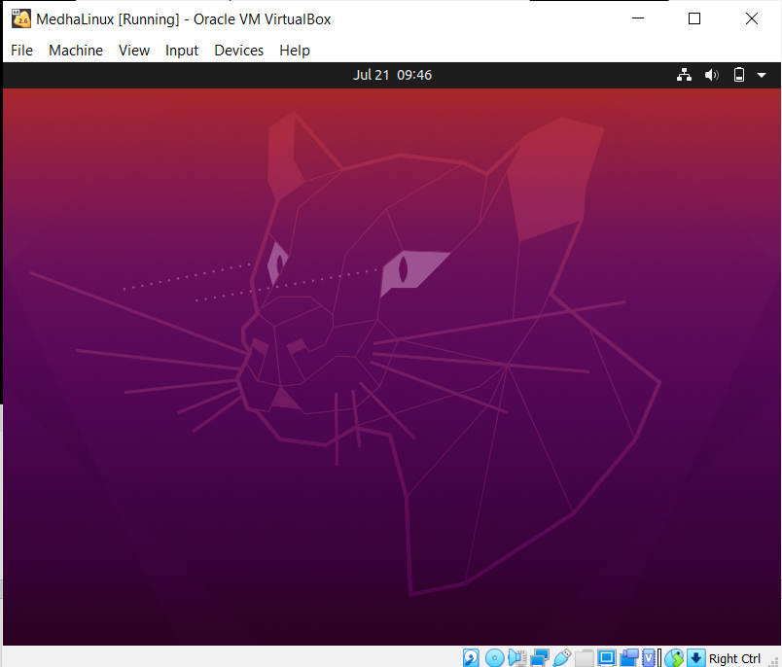

Step 25: Click on Install Ubuntu

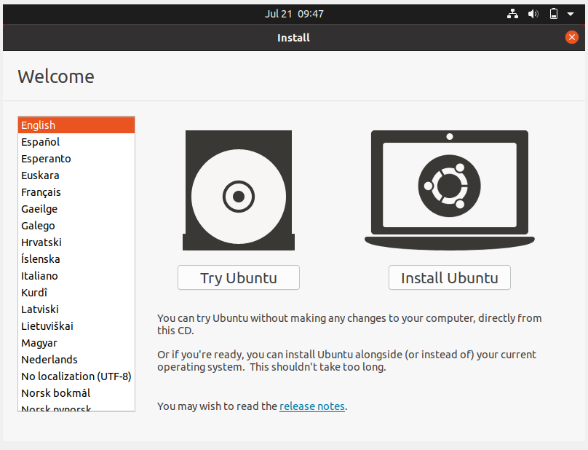

Step 26: Click on continue

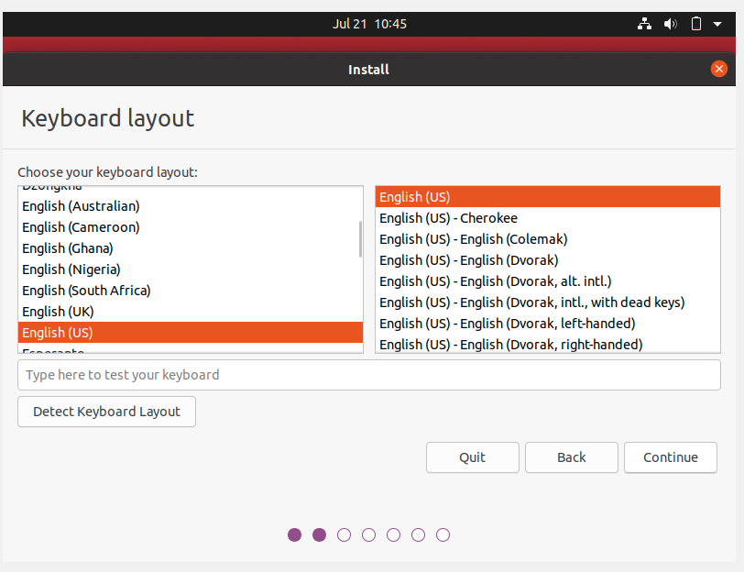

Step 27: Click on continue

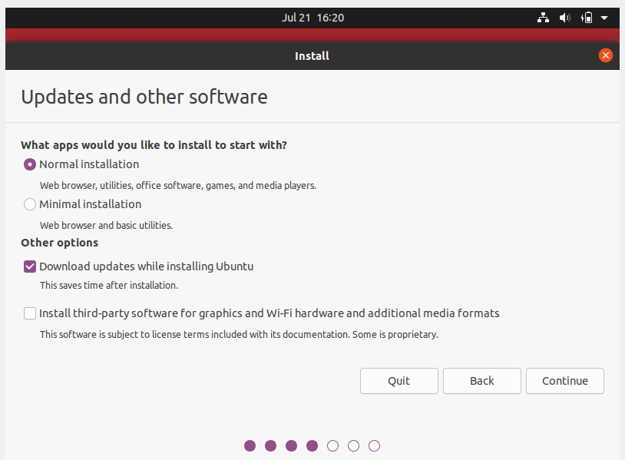

Step 28: Click on Install Now

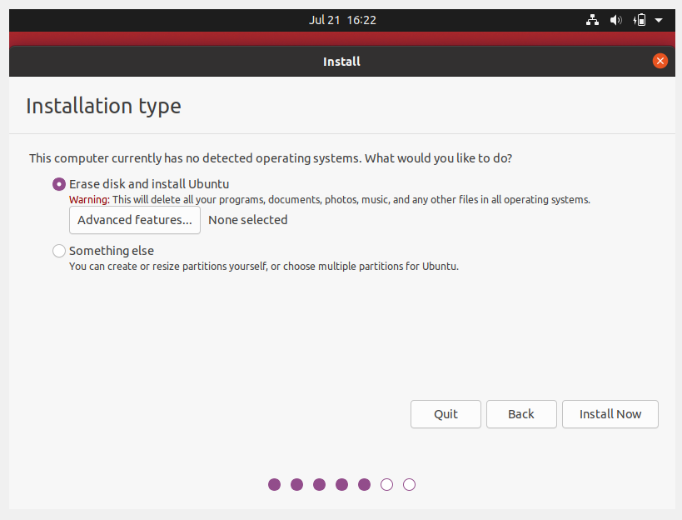

Step 29: Click on continue

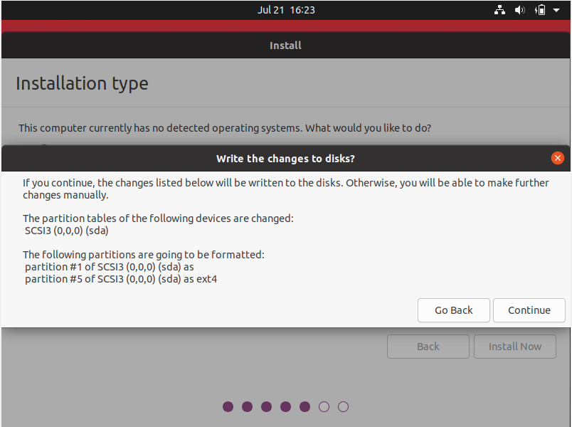

Step 30: Click on Continue

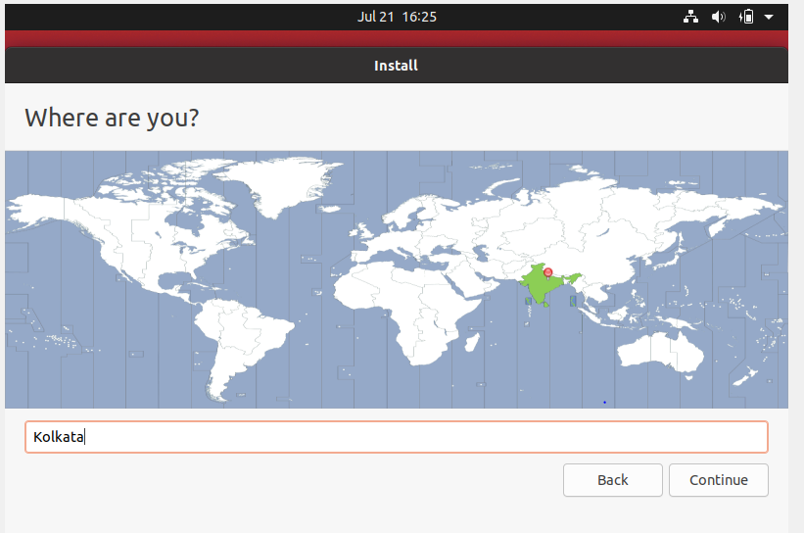

Step 31: Enter the required data and click on continue

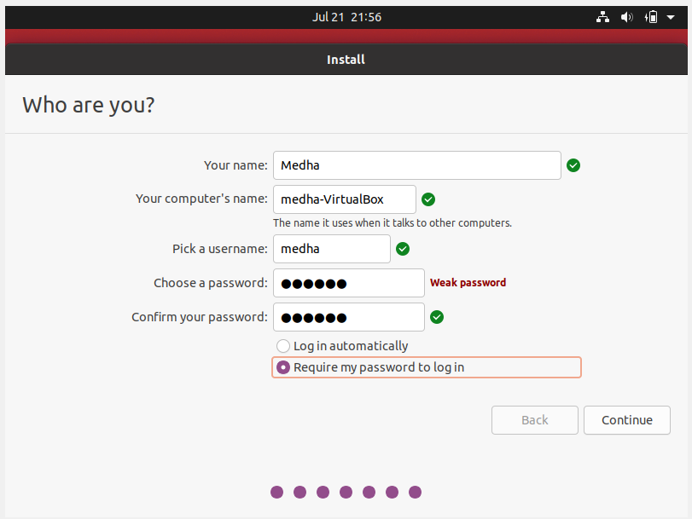

Step 31: The screen should look like this thereafter:

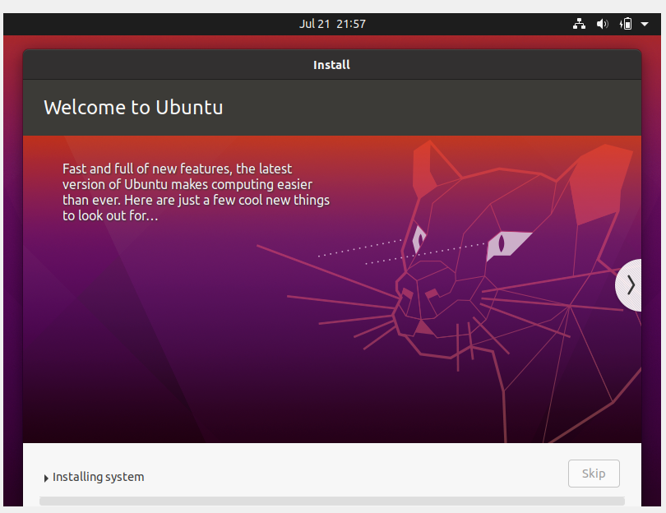

Step 32: Click on Restart Now

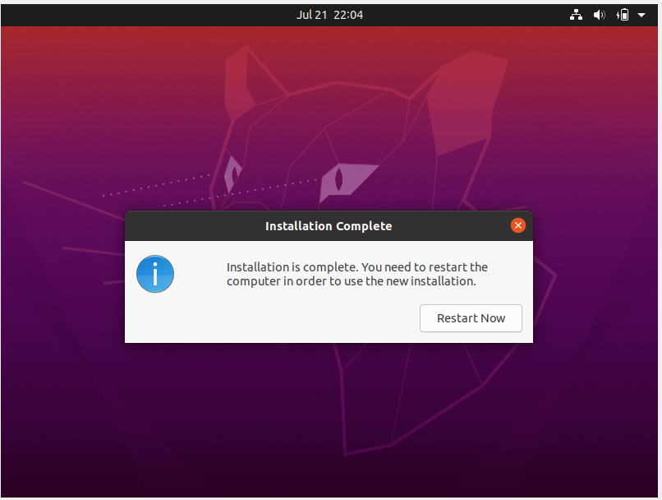

Step 33: The screen will look like this after restarting:

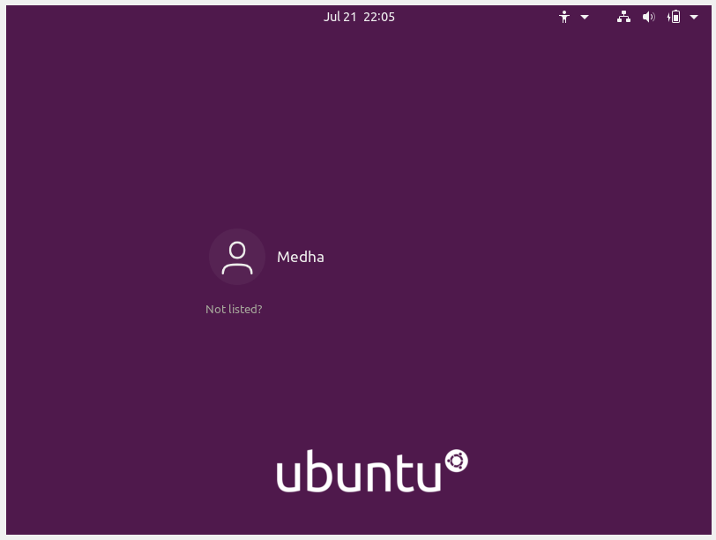

Step 34: Choose your account and enter credentials (password).

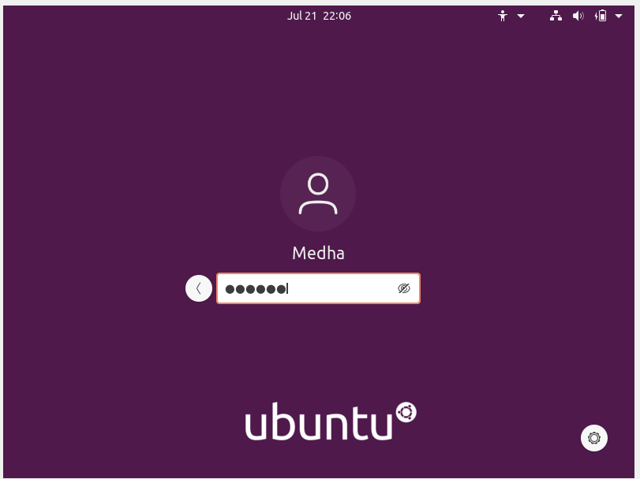

Step 35: Linux OS is successfully installed.

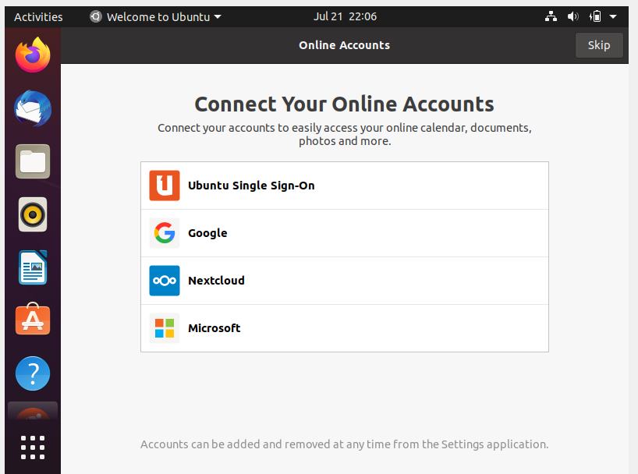

**RESULTS AND CONCLUSIONS:**

Linux Operating System was successfully installed.

# LAB 2

**AIM**: Study of Unix/Linux general purpose utility command list obtained from (man, who, cat, cd, cp, ps, ls, mv, rm, mkdir, rmdir, echo, more, date, time, kill, history, chmod, chown, id, pwd, cal, free, shutdown) commands.

**THEORY**:

|  |  |
| --- | --- |
| COMMAND | DESCRIPTION |
| pwd | Print name of current/working directory |
| cd | To change the directory |
| ls | List directory contents |
| cat | Concatenates files and prints on standard output |
| mkdir | Make directories |
| rmdir | Remove empty directories |
| touch | Change file timestamps |
| find | Search for files in a directory hierarchy |
| grep | Print lines that match patterns |
| du | Estimate file space usage |
| head | Output the first part of files |
| tail | Output the last part of files |
| chmod | Change file mode bits |
| man | An interface to the system reference manuals |
| who | Show who is logged in |
| cp | Copy files and directories |
| ps | Report a snapshot of current processes |
| mv | Move (rename) files |
| rm | Remove files or directories |
| echo | Display a line of text |
| more | File perusal filter for crt viewing |
| date | Print or set the system date and time |
| time | Run programs and summarize system resource usage |
| kill | Send a signal to a process |
| history | GNU history library |
| chown | Change file owner and group |
| id | Print real and effective user and group IDs |
| cal | Displays a calendar and the date of Easter |
| free | Display amount of free and used memory in the system |
| shutdown | Halt, power off or reboot the machine |

**PROCEDURE**:

COMMAND 1: pwd

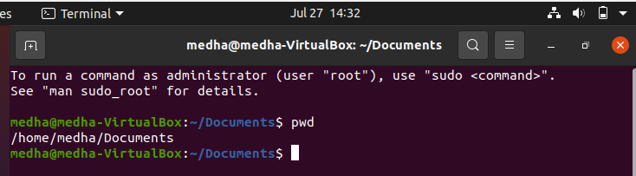

COMMAND 2: cd

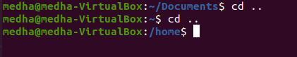

COMMAND 3: ls

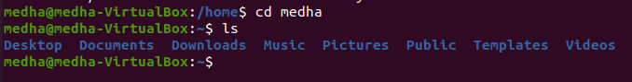

COMMAND 3.1: ls -ltr

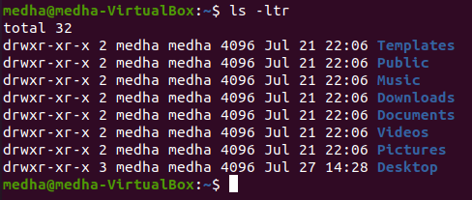

COMMAND 3.2: ls -R

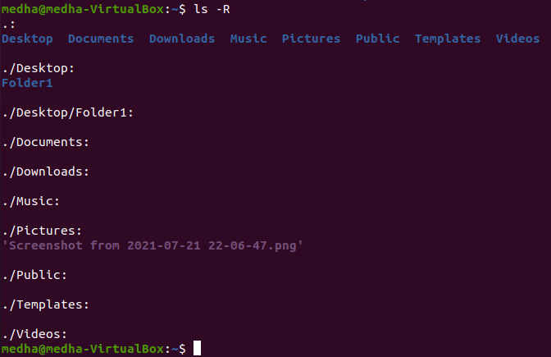

COMMAND 3.3: ls -a

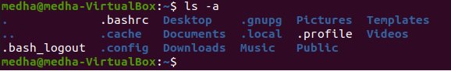

COMMAND 3.4: ls -al

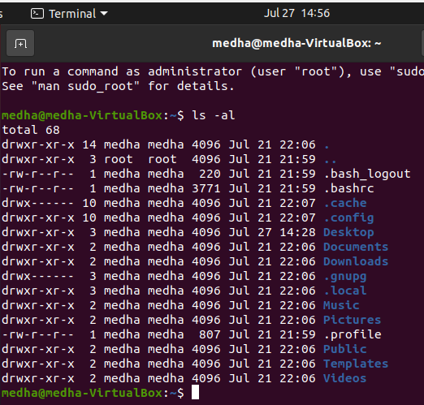

COMMAND 4: cat

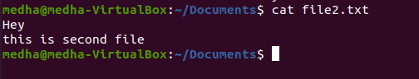

COMMAND 5: mkdir

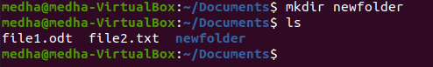

COMMAND 6: rmdir

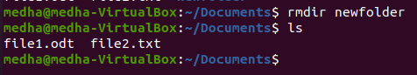

COMMAND 7: touch

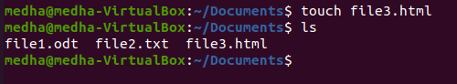

COMMAND 8: find

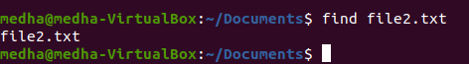

COMMAND 9: grep

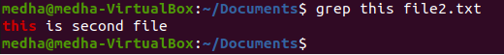

COMMAND 10: du

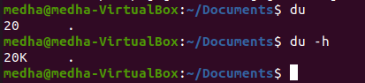

COMMAND 11: head

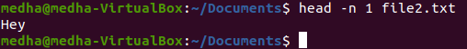

COMMAND 12: tail

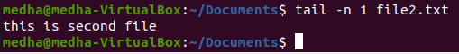

COMMAND 13: chmod

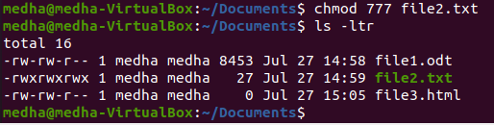

COMMAND 14: man



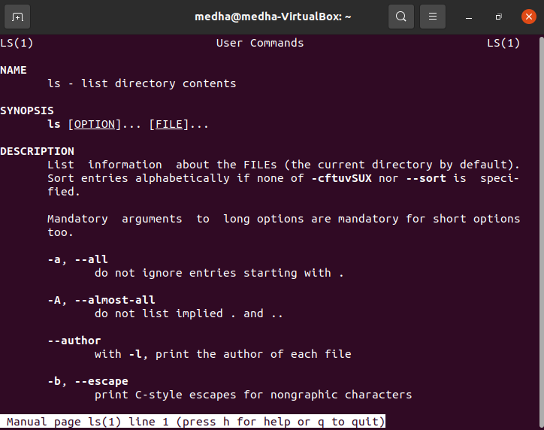

COMMAND 15: who

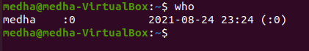

COMMAND 16: cp

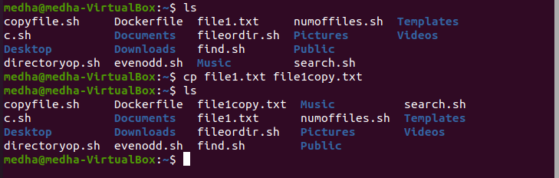

COMMAND 17: ps

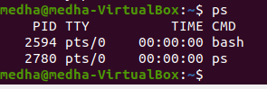

COMMAND 18: mv

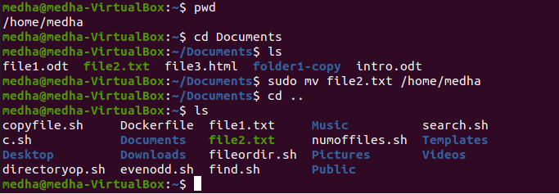

COMMAND 19: rm

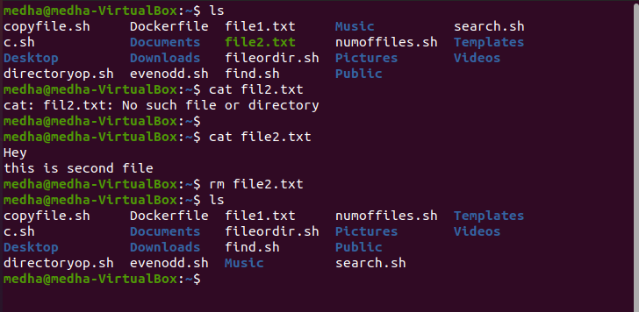

COMMAND 20: echo

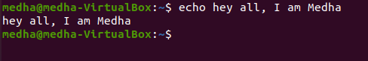

COMMAND 21: more

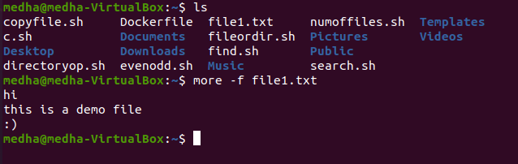

COMMAND 22: date



COMMAND 23: time

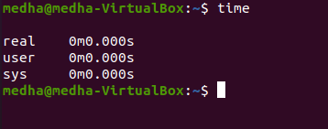

COMMAND 24: kill

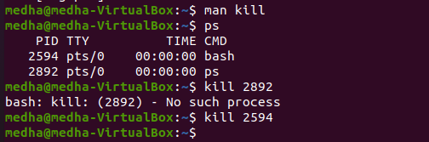

COMMAND 25: history

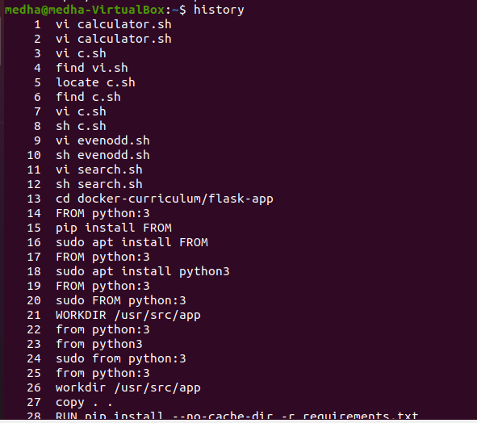

COMMAND 26: chown

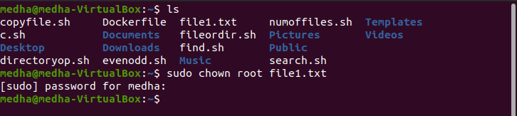

COMMAND 27: id

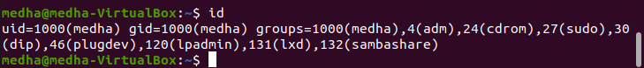

COMMAND 28: cal

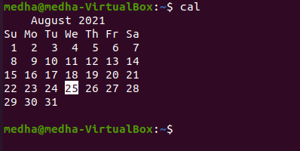

COMMAND 29: free

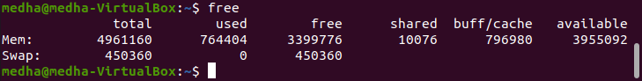

COMMAND 30: shutdown

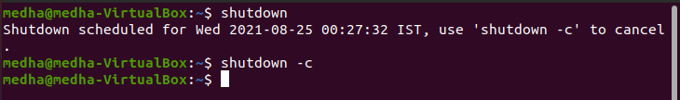

**RESULTS AND CONCLUSIONS:**

Unix/Linux general purpose utility command list obtained from (man, who, cat, cd, cp, ps, ls, mv, rm, mkdir, rmdir, echo, more, date, time, kill, history, chmod, chown, id, pwd, cal, free, shutdown) commands were studied.

LAB 3

**AIM**: To perform various operation on VI Editor

**PROCEDURE:**

* vi filename - Creates a new file if it already does not exist, otherwise opens an existing file.

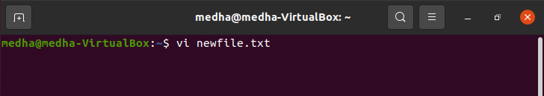

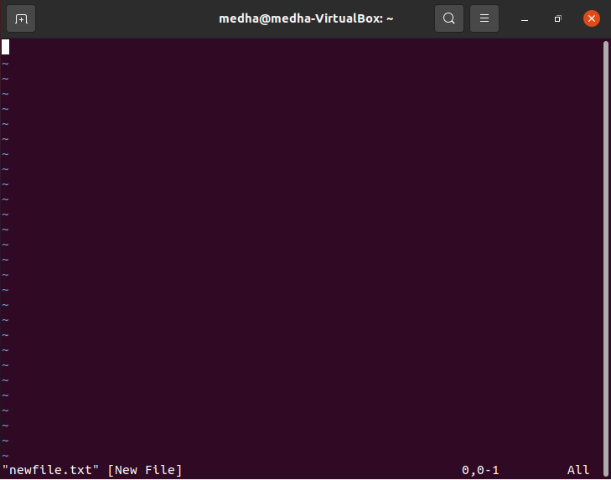

* vi -R - filename Opens an existing file in the read-only mode.

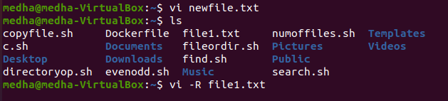

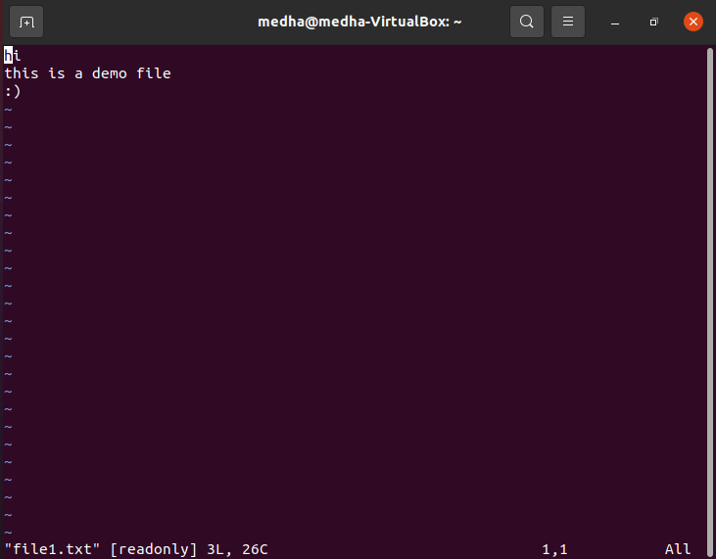

* view filename - Opens an existing file in the read-only mode.



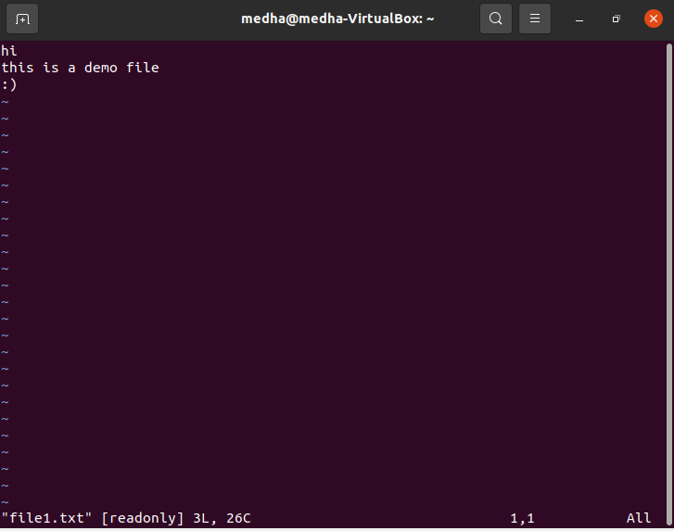

Deleting Characters

* x Deletes - the character under the cursor location



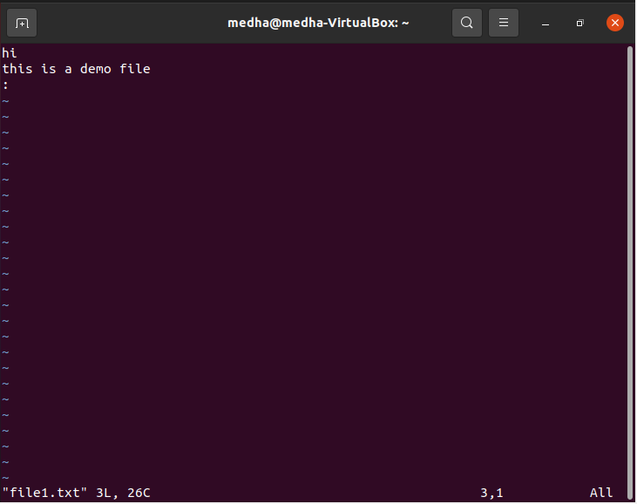

* X - Delets the character before the cursor location

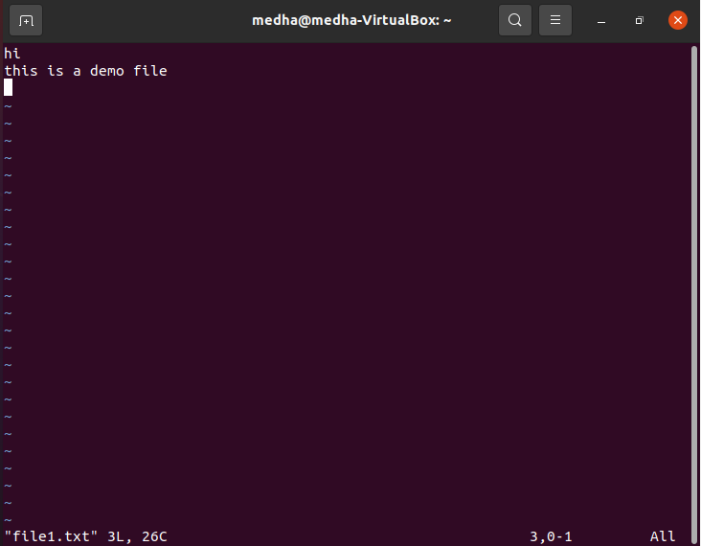

* dw - Deletes from the current cursor location to the next word

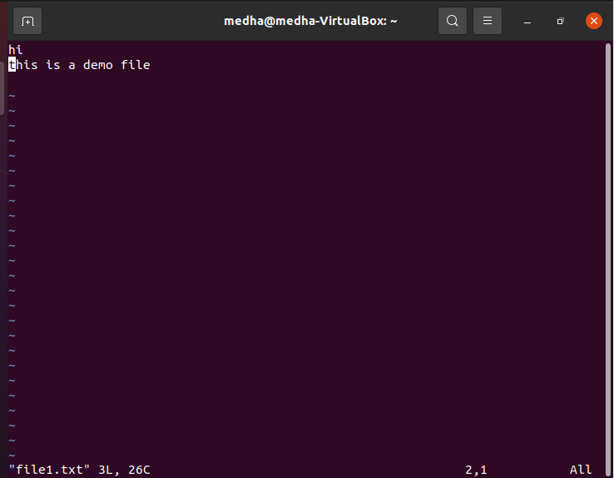

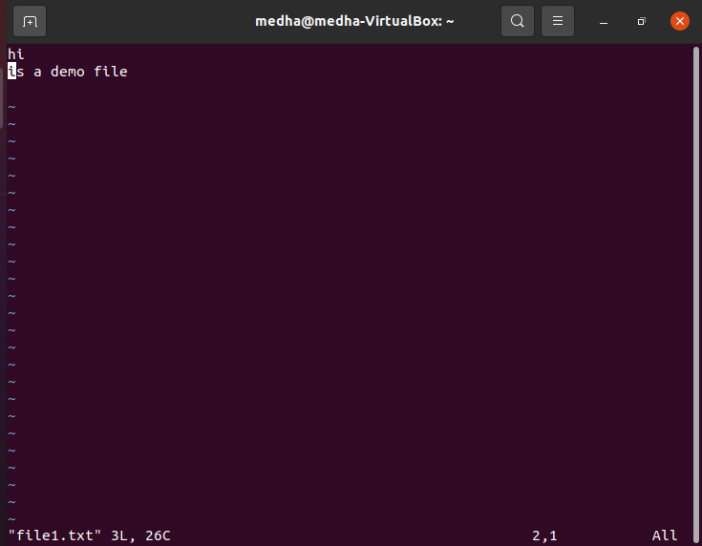

* d^ - Deletes from the current cursor position to the beginning of the line

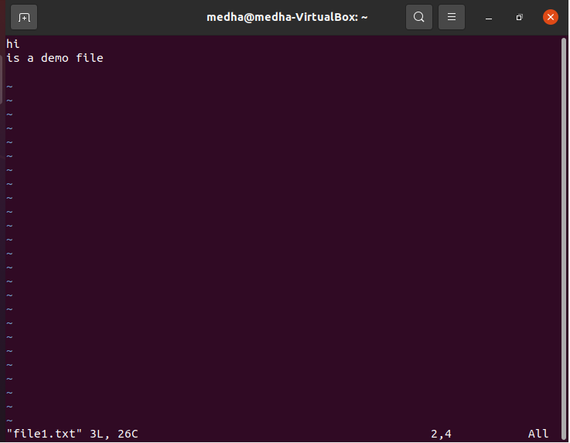

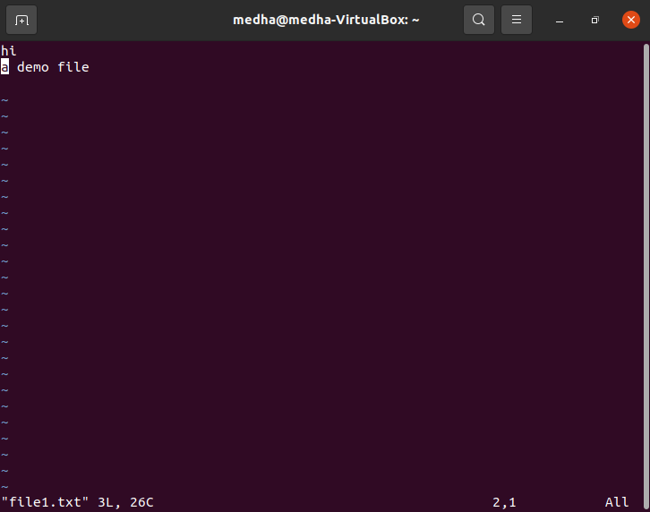

Advanced Commands

There are some advanced commands that simplify day-to-day editing and allow for more efficient use of vi –

* J- Joins the current line with the next one. A count of j commands joins many lines.

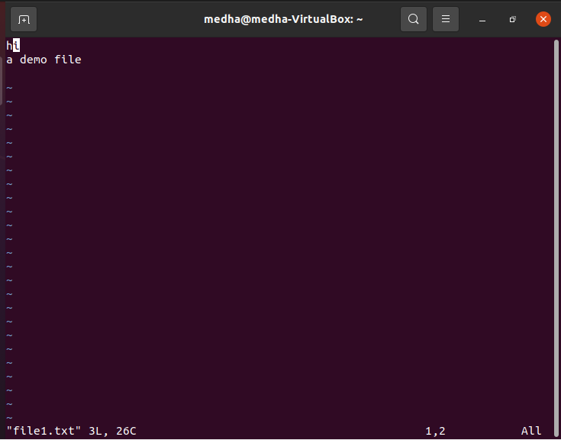

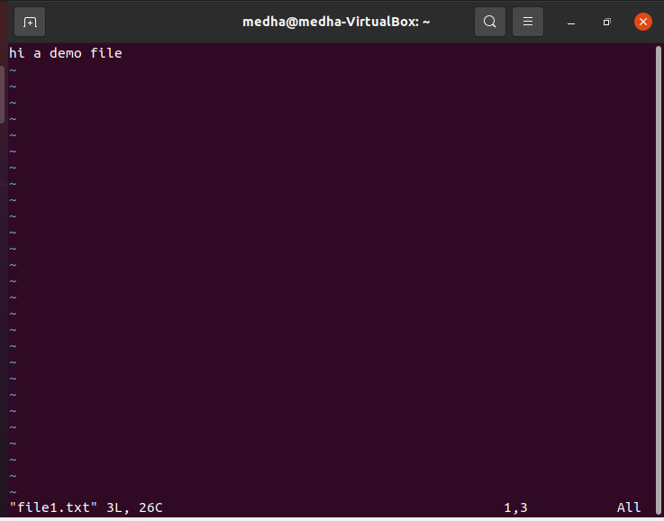

* >> Shifts – the current line to the right by one shift width.

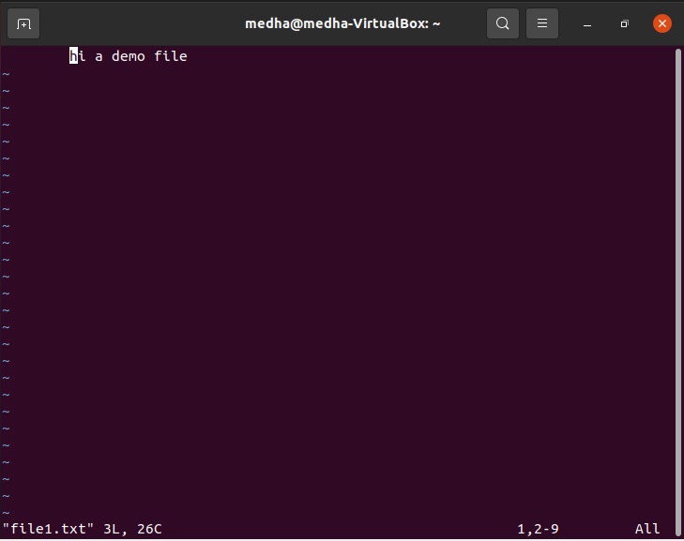

* << Shifts – the current line to the left by one shift width

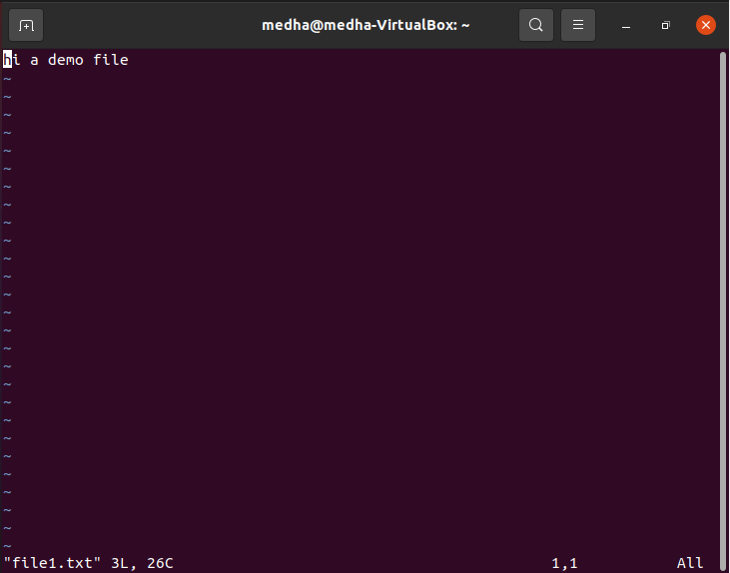

* ^G- Press Ctrl and G keys at the same time to show the current filename and the status.

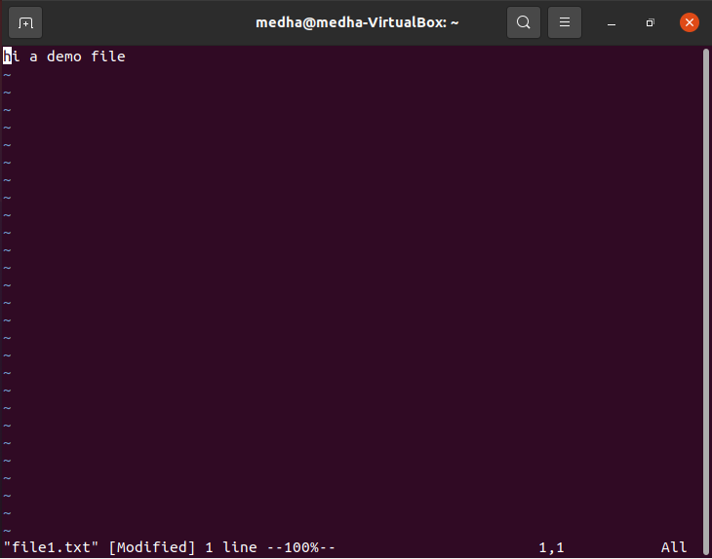

* u- This helps undo the last change that was done in the file. Typing ‘u’ again will re-do the change.

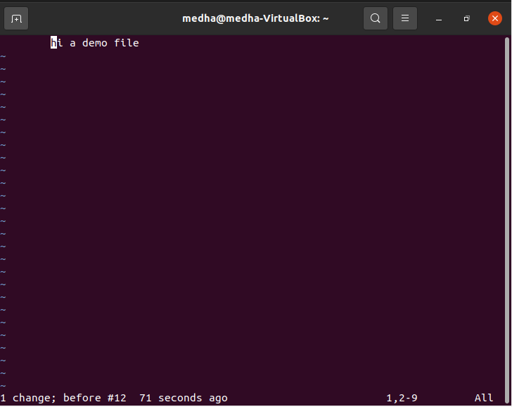

* :r -file Reads file and inserts it after the current line.

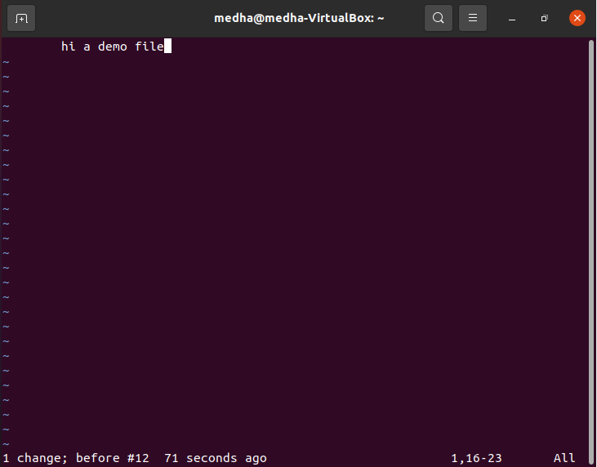

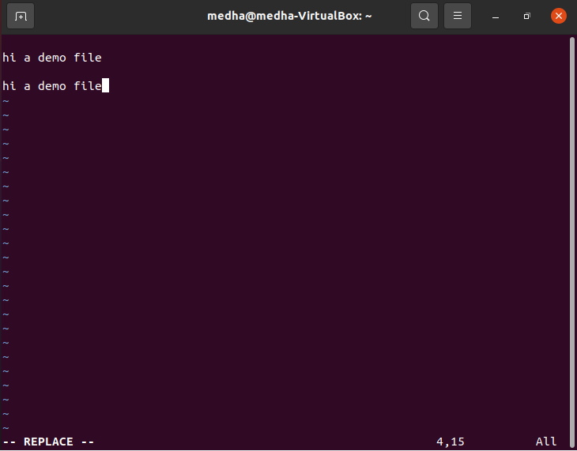

Word and Character Searching

Set Commands

: set term- Prints terminal type

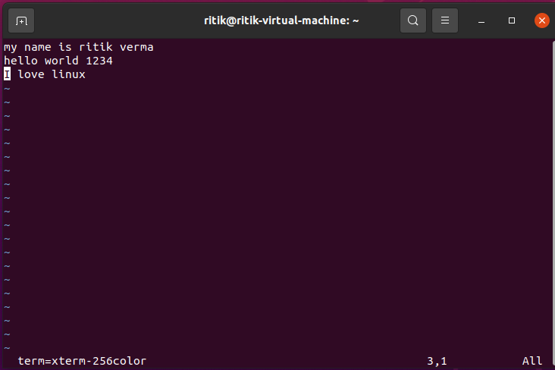

Running Commands

The vi has the capability to run commands from within the editor. To run a command, you only need to go to the command mode and type :! command. For example, if you want to check whether a file exists before you try to save your file with that filename, you can type :! ls and you will see the output of ls on the screen. You can press any key (or the command's escape sequence) to return to your vi session.

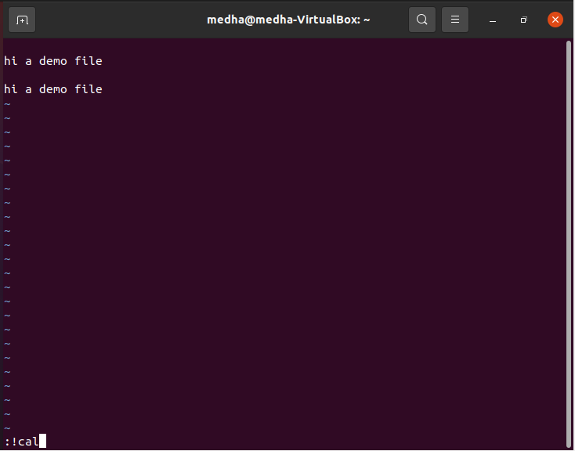

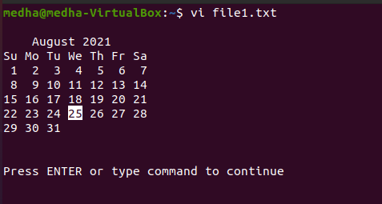

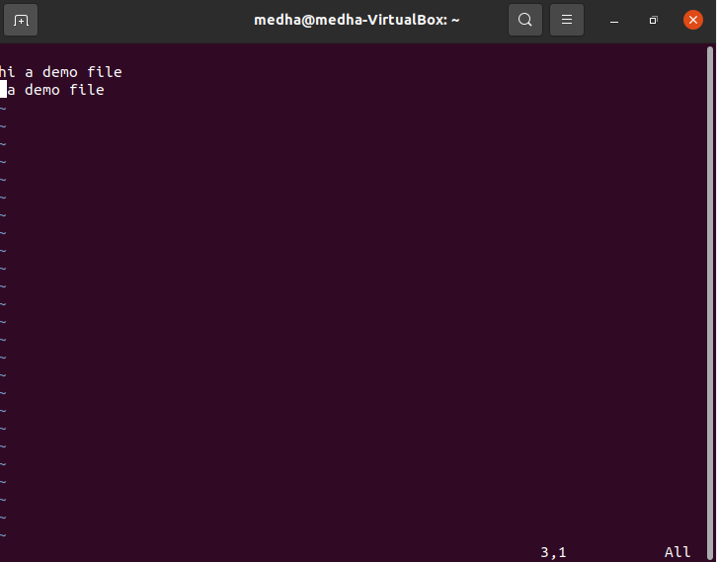

**RESULTS AND CONCLUSIONS:**

Various operation on VI Editor were performed successfully.

LAB 4

1. **AIM**: Implementation of simple calculator

**THEORY:**

The case statement allows us to easily check pattern (conditions) and then process a command-line if that condition evaluates to true. In other words, the $variable-name is compared against the patterns until a match is found. **\*)** acts as default and it is executed if no match is found. The pattern can include wildcards. You must include **;;** at the end of each command. The shell executes all the statements up to the two semicolons that are next to each other. The **esac** is always required to indicate end of case statement.

**PROCEDURE:**

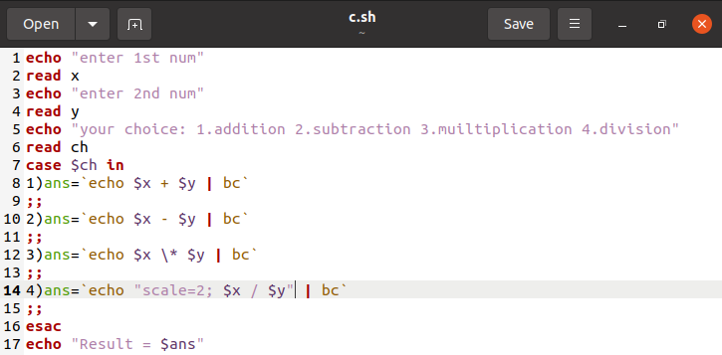

**RESULTS** **AND CONCLUSIONS:**

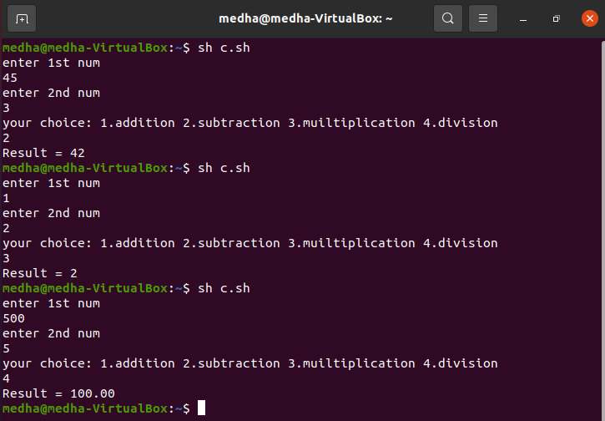

1. **AIM**: To identify a given number as even or odd

**THEORY:**

An if-then-else statement, return a zero exit code if the command is successful and if the command fails returns a non-zero value. If the command returns the non-zero exit code, the bash shell just moves on to the next command in the shell script.

**PROCEDURE:**

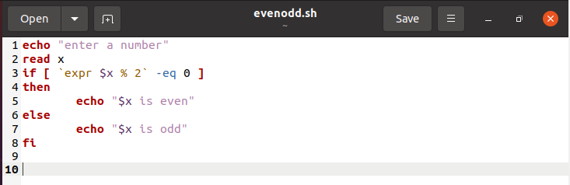

**RESULTS** **AND CONCLUSIONS:**

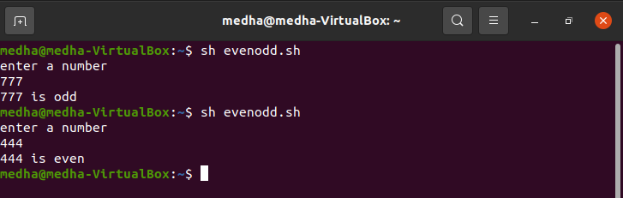

1. **AIM**: To find a given number in the list

**THEORY:**

The while loop enables you to execute a set of commands repeatedly until some condition occurs. It is usually used when you need to manipulate the value of a variable repeatedly.

**PROCEDURE:**

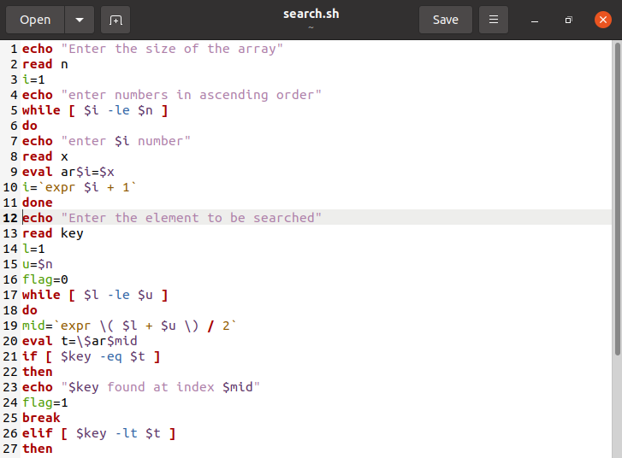

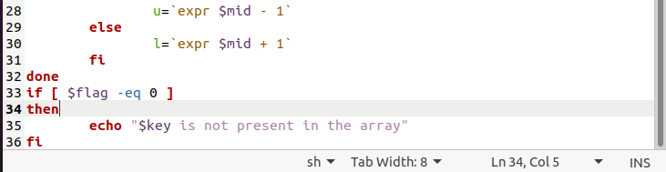

**RESULTS** **AND CONCLUSIONS:**

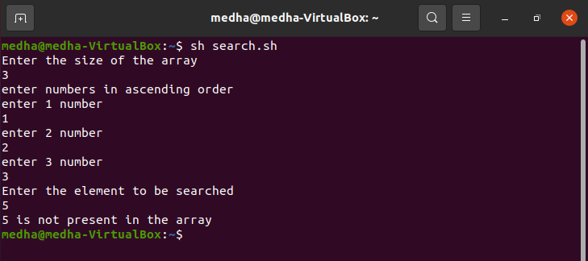

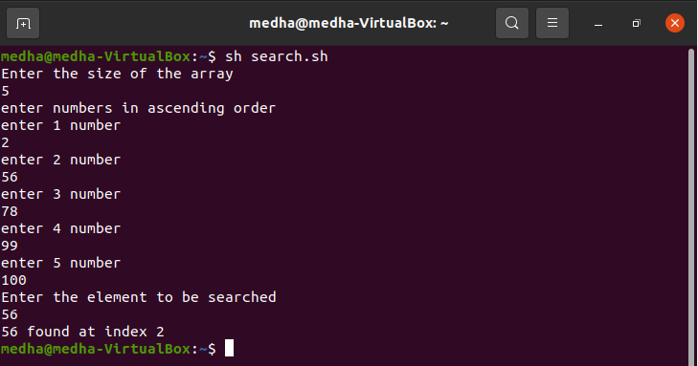

LAB 5

**AIM**: Implementation of Docker on Linux Operating System

**THEORY:**

Docker is an open platform for developing, shipping, and running applications. Docker enables you to separate your applications from your infrastructure so you can deliver software quickly. With Docker, you can manage your infrastructure in the same ways you manage your applications. By taking advantage of Docker’s methodologies for shipping, testing, and deploying code quickly, you can significantly reduce the delay between writing code and running it in production.

Docker provides the ability to package and run an application in a loosely isolated environment called a container. The isolation and security allow you to run many containers simultaneously on a given host. Containers are lightweight and contain everything needed to run the application, so you do not need to rely on what is currently installed on the host. You can easily share containers while you work, and be sure that everyone you share with gets the same container that works in the same way.

* Docker provides tooling and a platform to manage the lifecycle of your containers:
* Develop your application and its supporting components using containers.
* The container becomes the unit for distributing and testing your application.
* When you’re ready, deploy your application into your production environment, as a container or an orchestrated service. This works the same whether your production environment is a local data centre, a cloud provider, or a hybrid of the two.

Docker uses a client-server architecture. Dockers can be used for Fast, consistent delivery of your applications, Responsive deployment and scaling and running more workloads on the same hardware. Docker is written in the Go programming language and takes advantage of several features of the Linux kernel to deliver its functionality. Docker uses a technology called namespaces to provide the isolated workspace called the container. When you run a container, Docker creates a set of namespaces for that container. These namespaces provide a layer of isolation. Each aspect of a container runs in a separate namespace and its access is limited to that namespace.

**PROCEDURE:**

1. Search “Docker Implementation Ubuntu” on Google

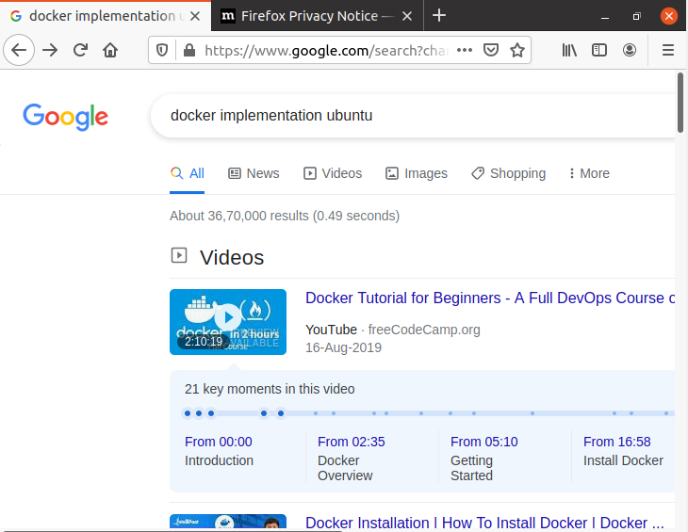

1. Click on the “Overview – Docker Documentation” link

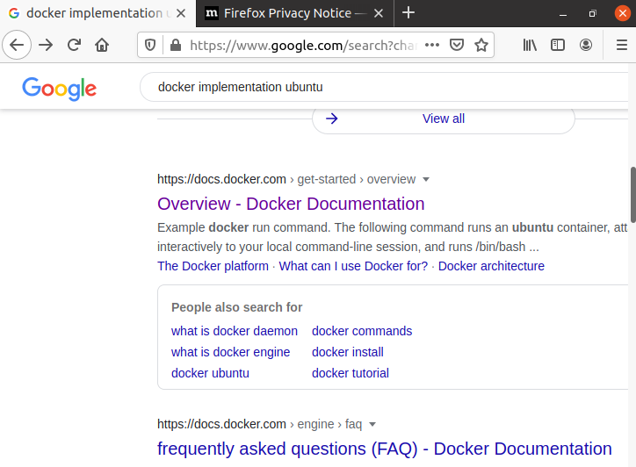

1. The following screen will appear. Read the documentation.

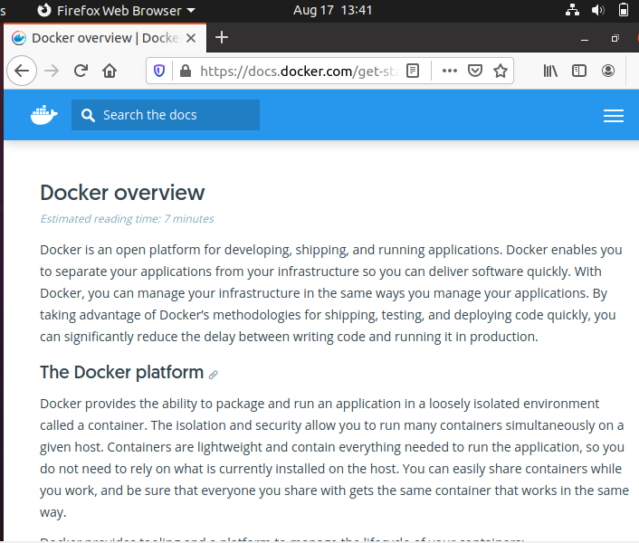

1. Go to the following link: <https://docs.docker.com/engine/install/ubuntu/>

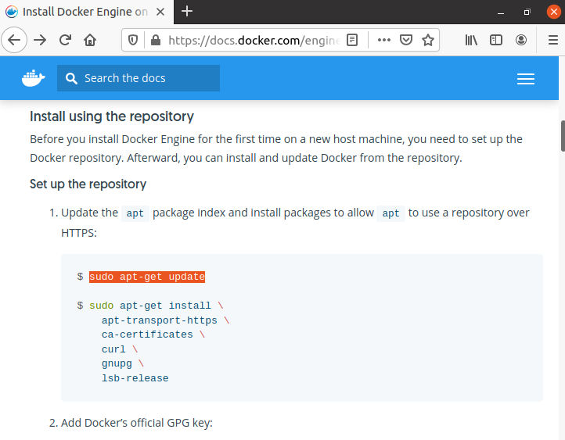

1. Set up the repository
   1. Update the apt package index and install packages to allow apt to use a repository over HTTPS:
      1. sudo apt-get update

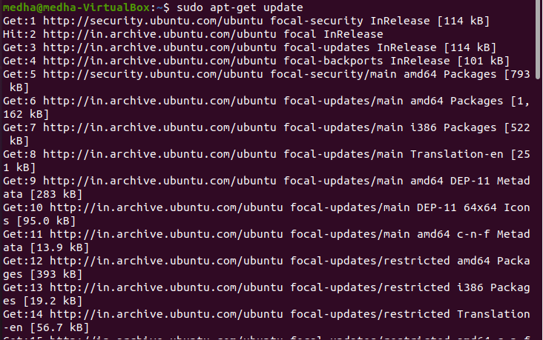

* + 1. sudo apt-get install \

apt-transport-https \

ca-certificates \

curl \

gnupg \

lsb-release

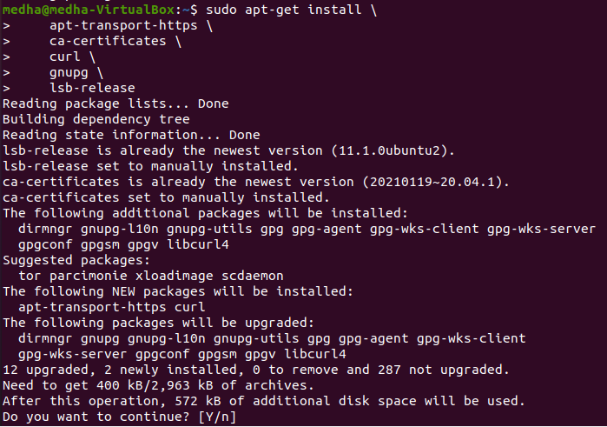

* 1. Add Docker’s official GPG key:

curl -fsSL https://download.docker.com/linux/ubuntu/gpg | sudo gpg --dearmor -o /usr/share/keyrings/docker-archive-keyring.gpg



* 1. Use the following command to set up the stable repository.

$ echo \

"deb [arch=amd64 signed-by=/usr/share/keyrings/docker-archive-keyring.gpg] https://download.docker.com/linux/ubuntu \

$(lsb_release -cs) stable" | sudo tee /etc/apt/sources.list.d/docker.list > /dev/null

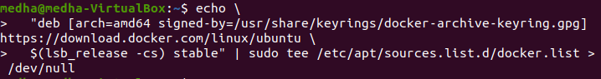

1. Install Docker Engine
2. Update the apt package index, and install the latest version of Docker Engine and containerd, or go to the next step to install a specific version:
   1. sudo apt-get update

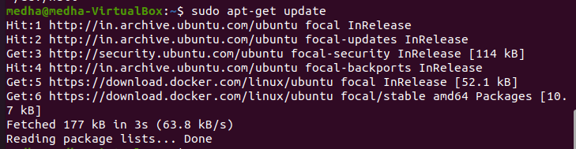

* 1. sudo apt-get install docker-ce docker-ce-cli containerd.io

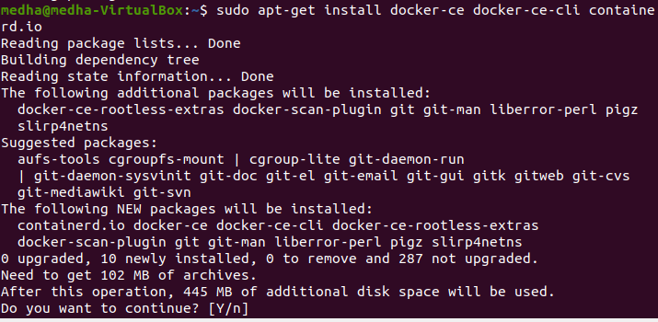

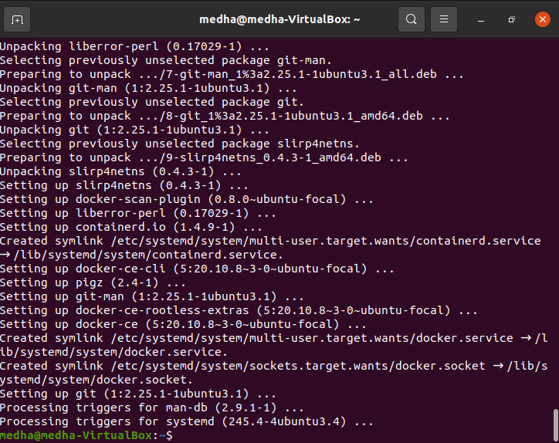

1. To install a specific version of Docker Engine, list the available versions in the repo, then select and install:
   * 1. List the versions available in your repo: $ apt-cache madison docker-ce 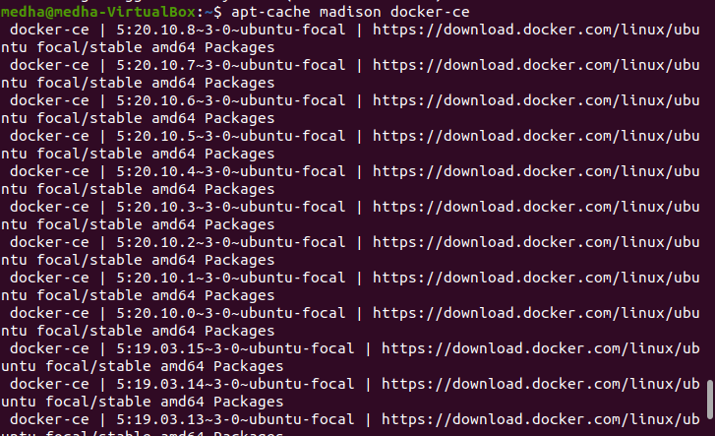
     2. Install a specific version using the <version string> from the second column:

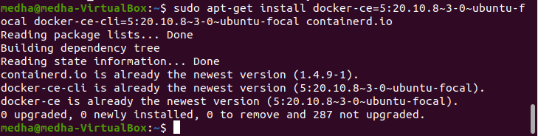

* + 1. Verify that Docker Engine is installed correctly by running the hello-world image.

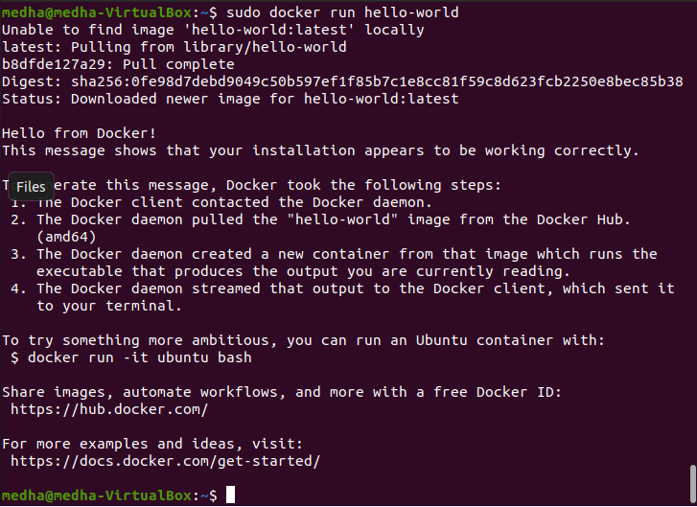

Commands to be implemented:

* Start

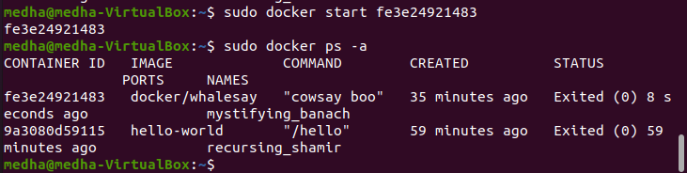

* Stop

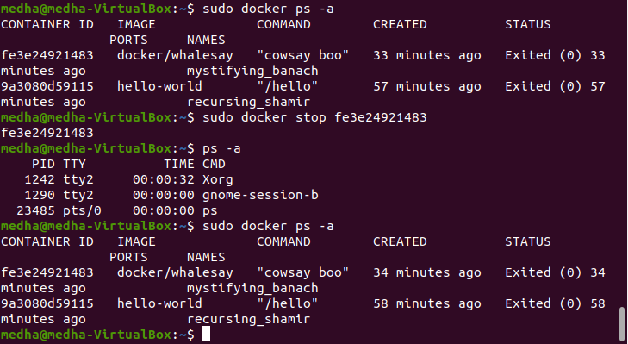

* Push
  + Creating our own images

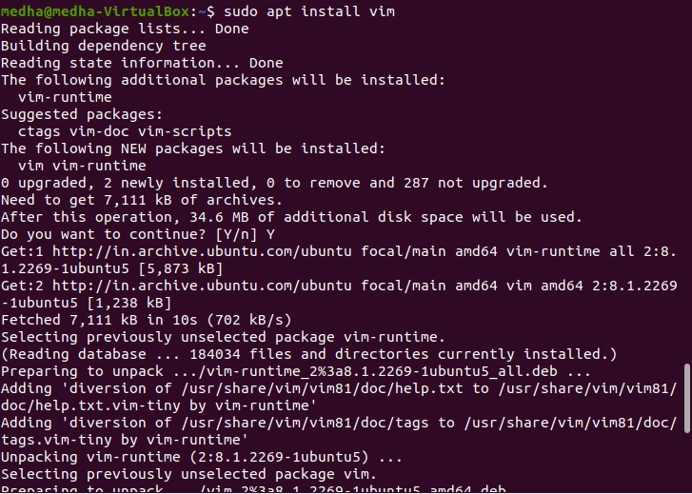

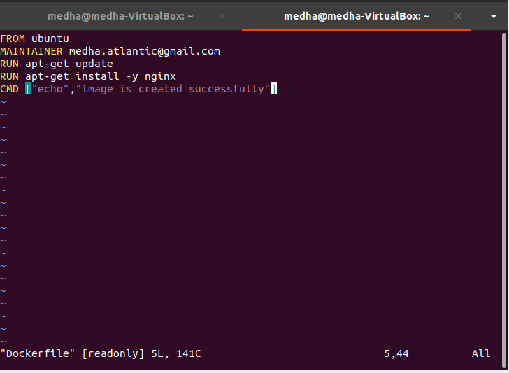

* + Docker – building files

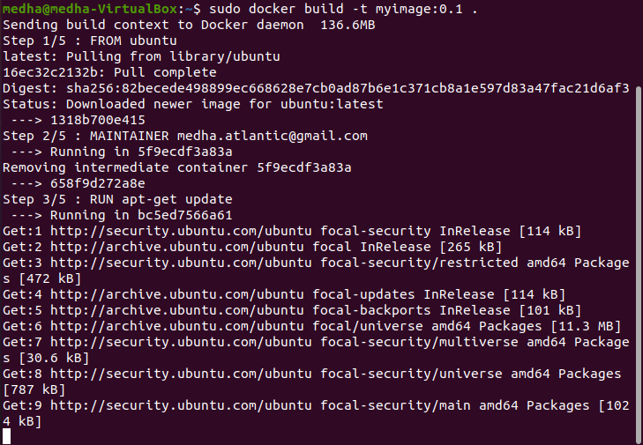

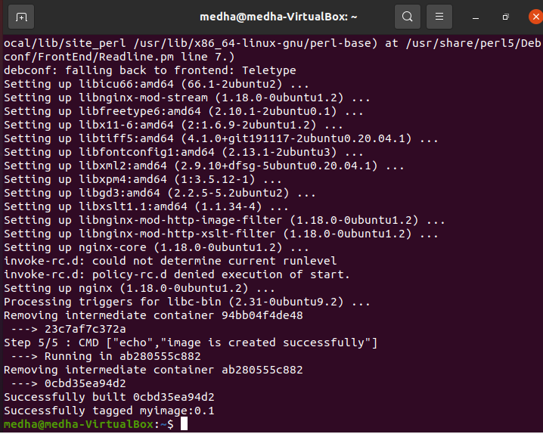

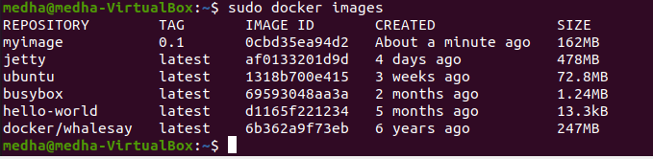

* + Docker – Public Repositories

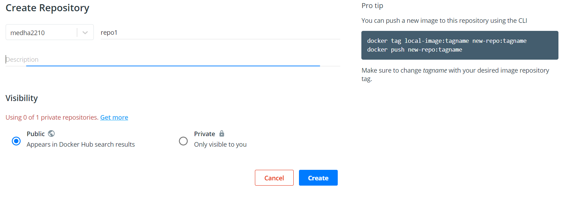

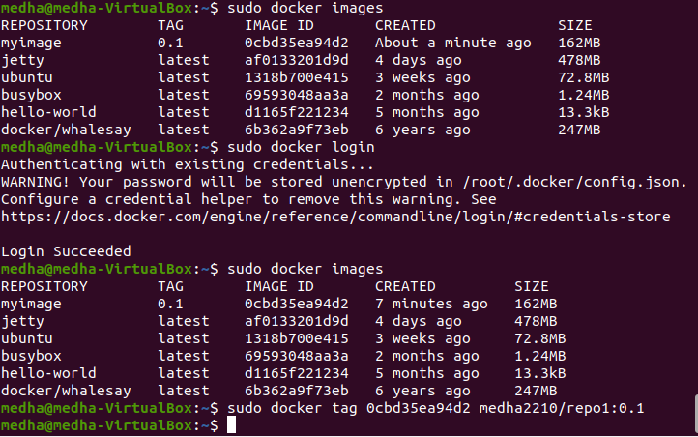

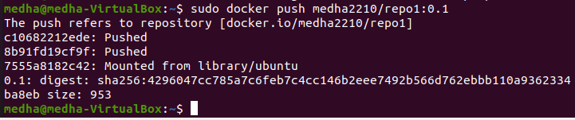

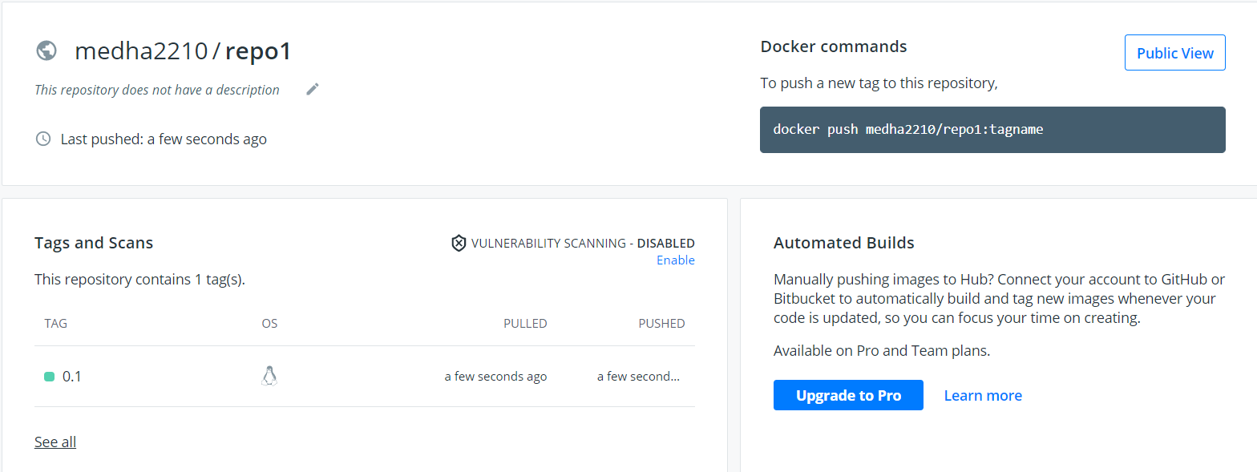

* Pull

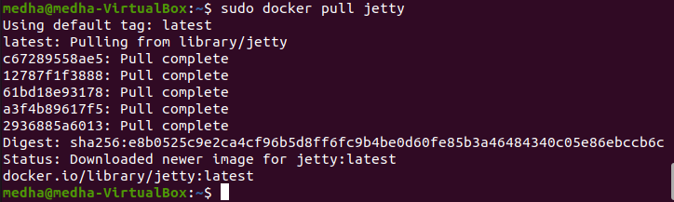

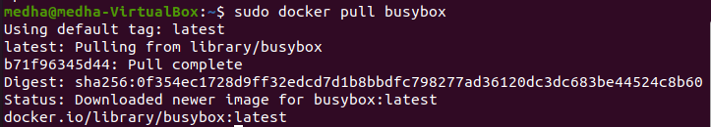

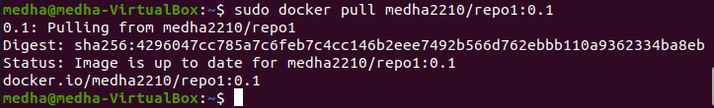

* Log

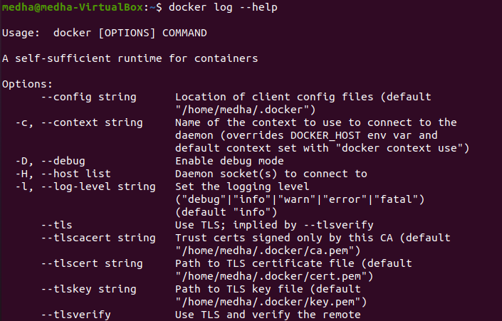

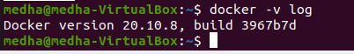

* docker ps



* docker ps -a

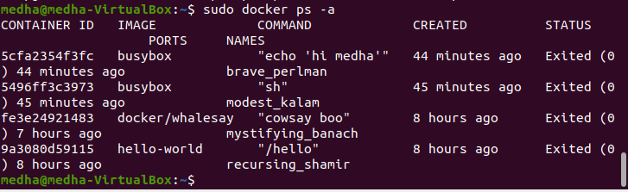

* create account on hub.docker.com as well

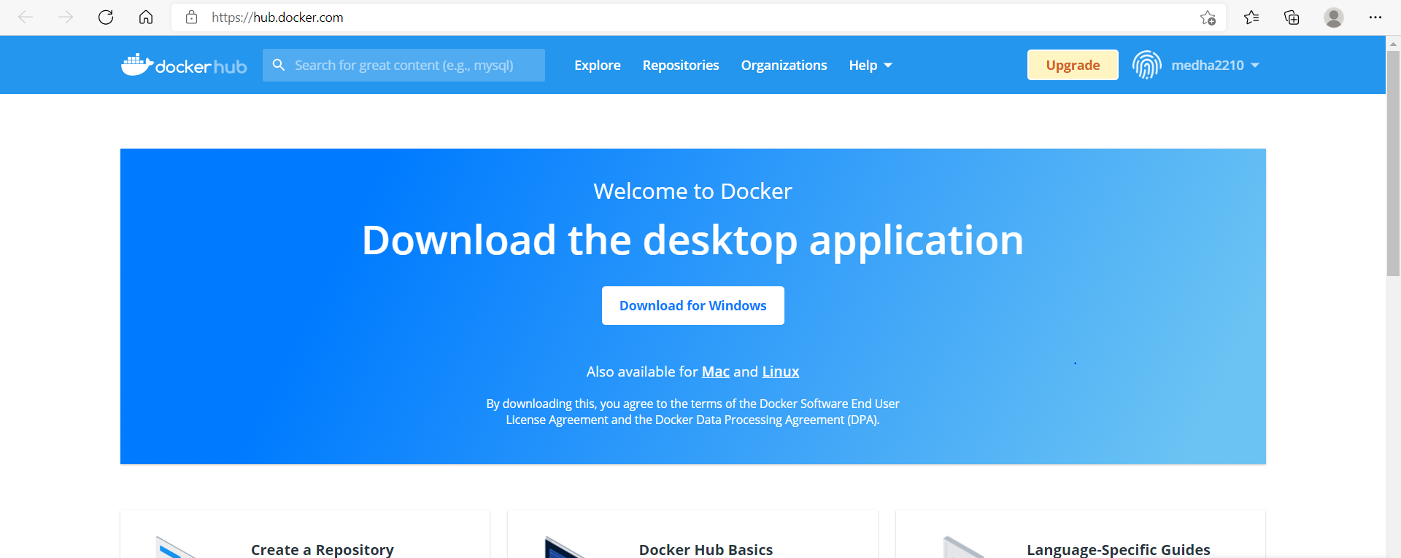

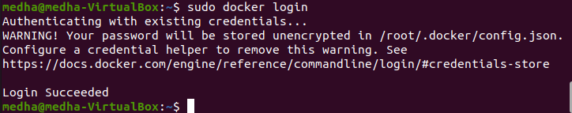

* docker compose

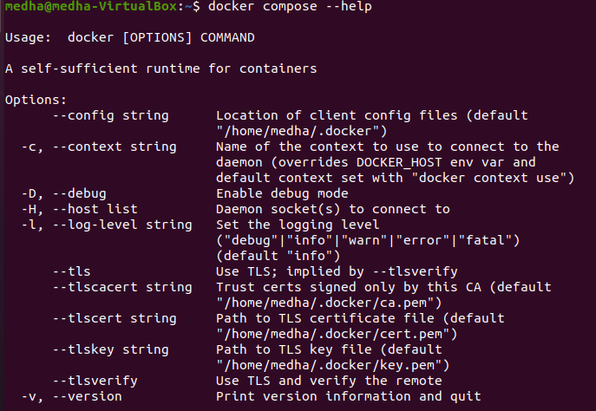

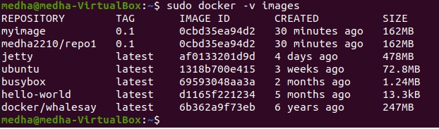

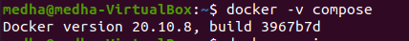

* docker build

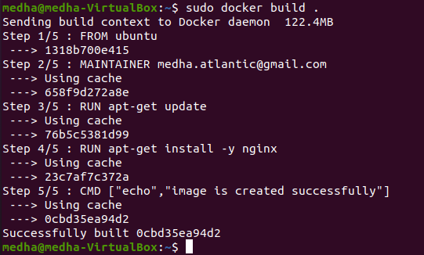

* docker run

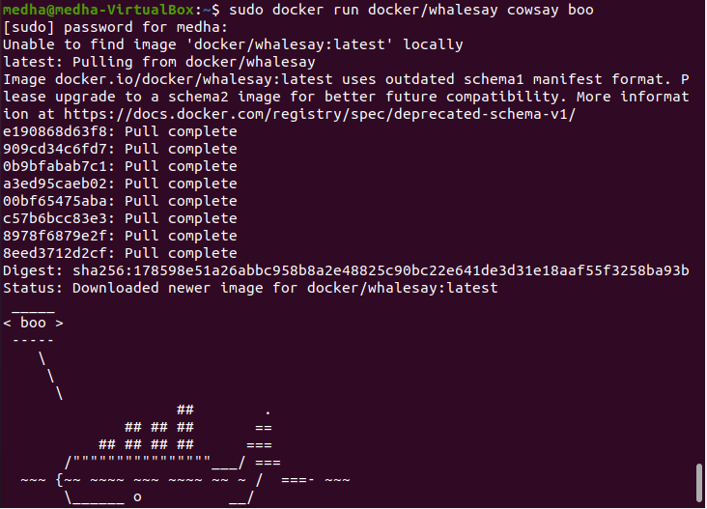



* docker images

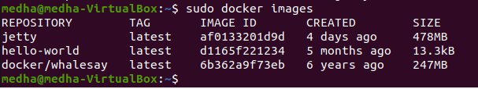

**RESULTS** **AND CONCLUSIONS:**

* Docker was installed successfully on Ubuntu Distribution of Linux.
* The commands like docker images, start, stop, push, pull, ps, ps -a, log, etc. were executed successfully.

LAB 6

1. **AIM: Shell script program to check whether given file is a directory or not.**
   * **THEORY:**
     1. **-f [PATH]** checks if the path is a file or not
     2. **-d [PATH]** checks if the path is a directory or not
   * **PROCEDURE:**

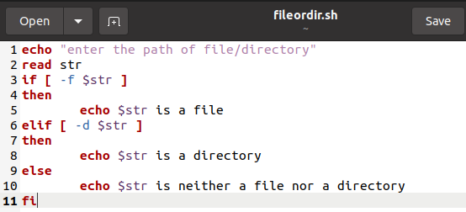

* + **RESULTS** **AND CONCLUSIONS:**

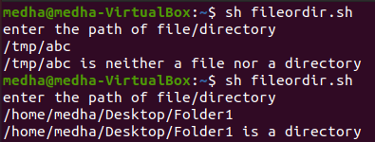

1. **AIM:** Shell script program to count number of files in a Directory.
   * **THEORY:**

If we want to get a count of all the files and directories execute this: wc -l is the "word count" command, and with the -l option counts only the lines. The above pipeline prints a number which is the number of files under your home directory**.**

* + **PROCEDURE:**

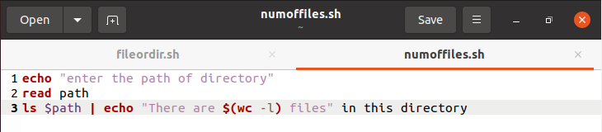

* + **RESULTS** **AND CONCLUSIONS:**

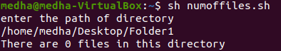

1. **AIM:** Shell script program to copy contents of one file to another.
   * **THEORY:**

**cat [oldfile] > [newfile]** copies content from older to new file.

* + **PROCEDURE:**

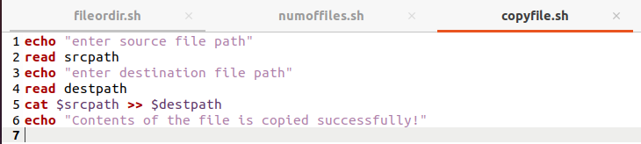

* + **RESULTS** **AND CONCLUSIONS:**

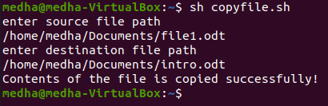

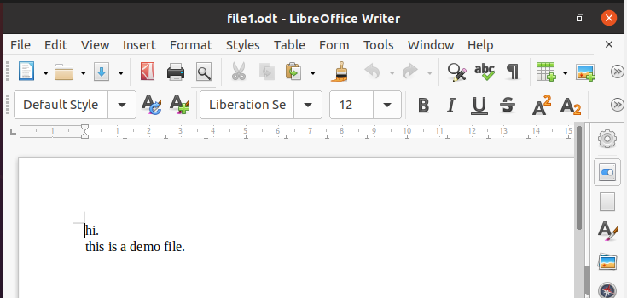

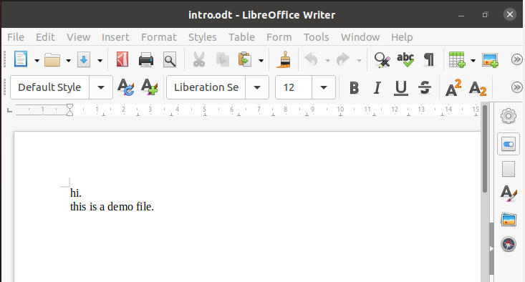

1. **AIM: Create directory, write contents on that and Copy to a suitable location in your home directory.**
   1. **THEORY:**
   * **cat > readme.txt** takes input from command line and copies to readme.txt
   * **mkdir** commandcreates directory
   * **touch** command creates an empty file.
   * **cp -R [source] [destination]** copies the source directory and its contents to destination directory
   1. **PROCEDURE:**

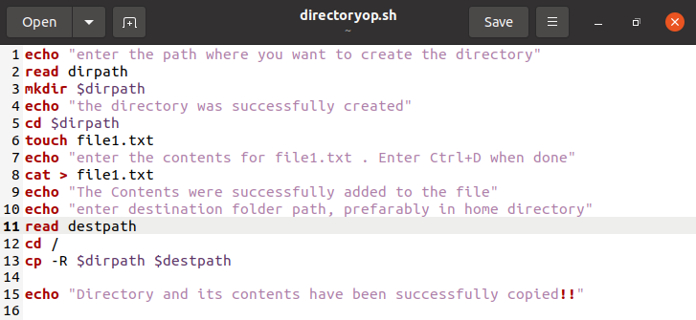

* 1. **RESULTS** **AND CONCLUSIONS:**

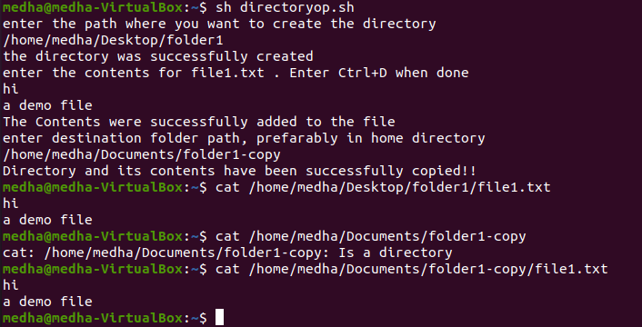

LAB 7

1. **AIM: Use a pipeline and command substitution to set the length of a line in file to a variable**
   * **THEORY:**
     1. **fmt:** simple optimal text formatter

**SYNOPSIS**

**fmt [-WIDTH] [OPTION]… [FILE]…**

Reformat each paragraph in a file, writing to standard output

* + **PROCEDURE:**

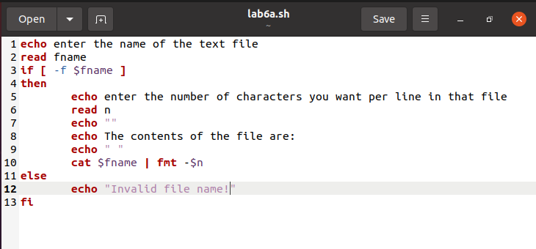

* + **RESULTS** **AND CONCLUSIONS:**

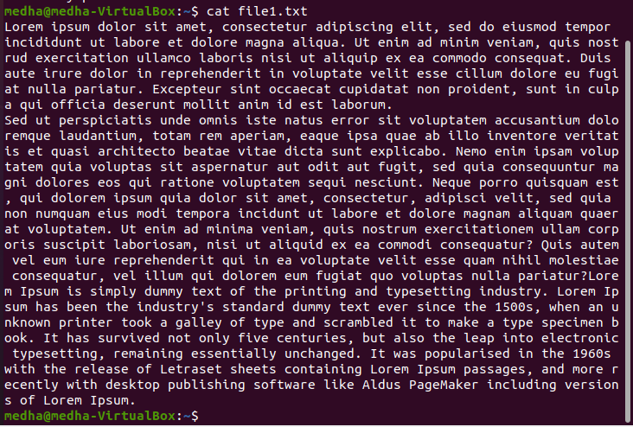

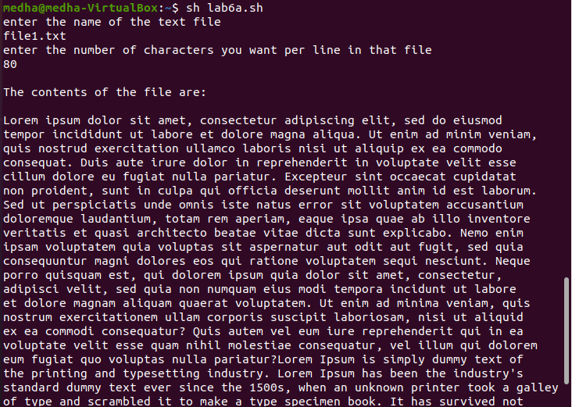

1. **AIM: Write a program using sed command to print duplicated lines of Input.**
   * **THEORY:**

**sed:** stream editor for filtering and transforming text

**DESCRIPTION**

SED command in UNIX is stands for stream editor and it can perform lots of function on file like, searching, find and replace, insertion or deletion. Though most common use of SED command in UNIX is for substitution or for find and replace. By using SED, you can edit files even without opening it, which is much quicker way to find and replace something in file, than first opening that file in VI Editor and then changing it.

* + 1. We read the next line from input with the N command which appends the next line to pattern space separated by "\n" character.
    2. $! prevents it from doing on the last line.
    3. The substitution replaces two repeating strings with one.
    4. The t command takes the script to the end where the current pattern space gets printed automatically.
    5. If the substitution was not successful, D executes, deleting the non-repeated string.
    6. The cycle continues and this way only the duplicate lines get printed once.
  + **PROCEDURE:**

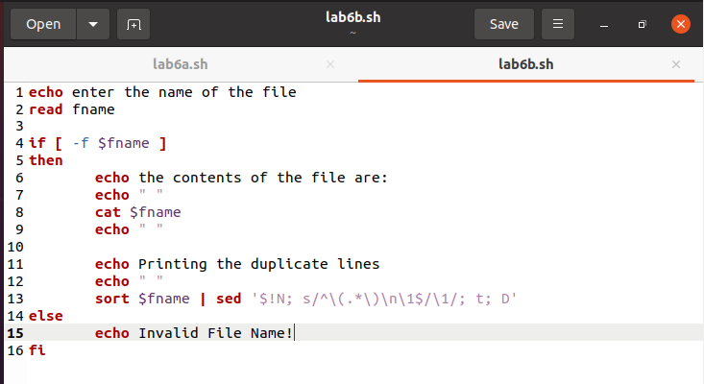

* + **RESULTS** **AND CONCLUSIONS:**

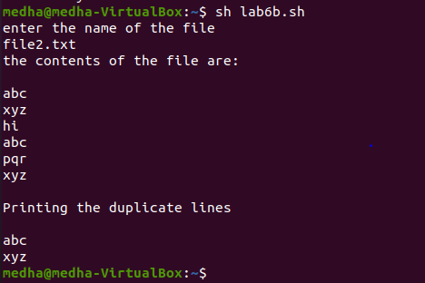

LAB 8

1. **AIM: Write a program to illustrate the implementation of integer comparison**
   * **THEORY:**

**NAME**

**test:** check file types and compare values

SYNOPSIS

test EXPRESSION

test

[EXPRESSION]

[ ]

[ OPTION

DESCRIPTION

Exit with the status determined by the expression

With the test command, you can compare integers, compare strings, and even perform logical operations. The command consists of the keyword test followed by the values being compared, separated by an option that specifies what kind of comparison is taking place. The option can be thought of as the operator, but it is written, like other options, with a minus sign and letter codes. For example, -eq is the option that represents the equality comparison. However, there are two string operations that actually use an operator instead of an option. When you compare two strings for equality, you use the equal sign (=). For inequality you use !=. Table 4-1 lists some of the commonly used options and operators used by test. The syntax for the test command is shown here: test value -option value test string = string

The exit status of the test command is examined to find out the result of the test operation. The shell special variable $? holds the exit status of the most recently executed Linux command.

* + **PROCEDURE:**

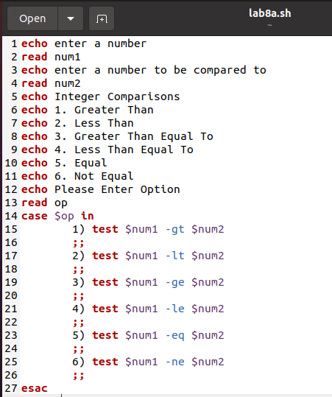

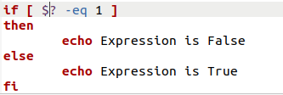

* + **RESULTS** **AND CONCLUSIONS:**

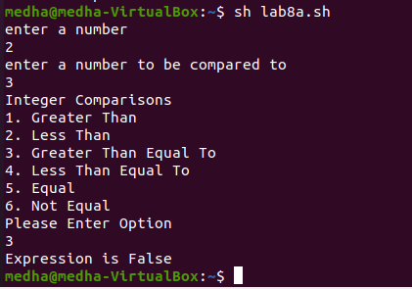

1. **AIM: Write a program to illustrate the implementation of string comparison**
   * **THEORY:**

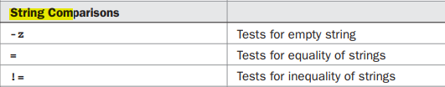

* + **PROCEDURE:**

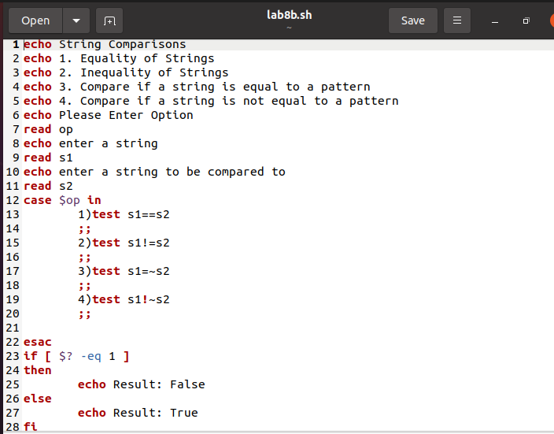

* + **RESULTS** **AND CONCLUSIONS:**

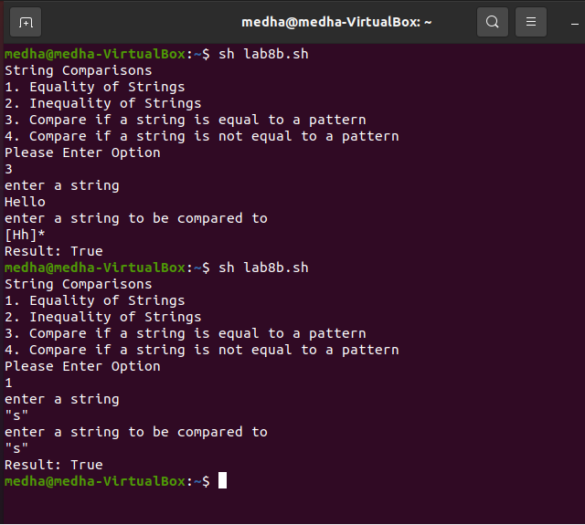

1. **AIM: Write a program to illustrate the implementation of logical operations**
   * **THEORY:**

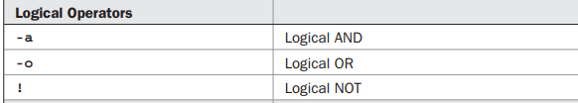

* + **PROCEDURE:**

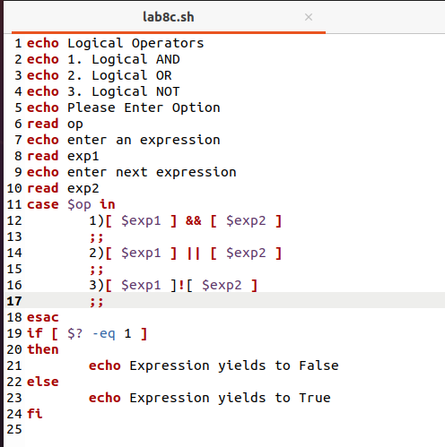

* + **RESULTS** **AND CONCLUSIONS:**

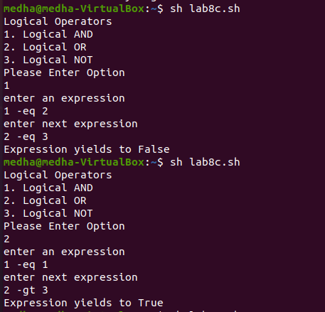

1. **AIM: Write a program to illustrate the implementation of file operations**
   * **THEORY:**

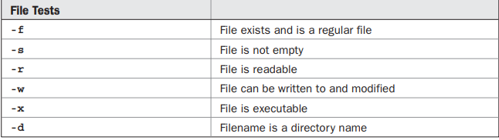

* + **PROCEDURE:**

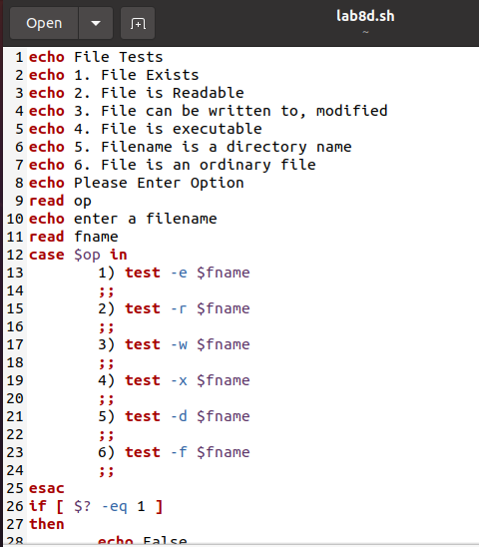

* + **RESULTS** **AND CONCLUSIONS:**

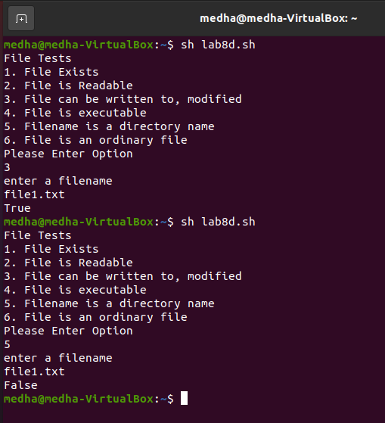

1. **AIM: Write a program to illustrate the implementation of conditional control structures**
   * **THEORY:**

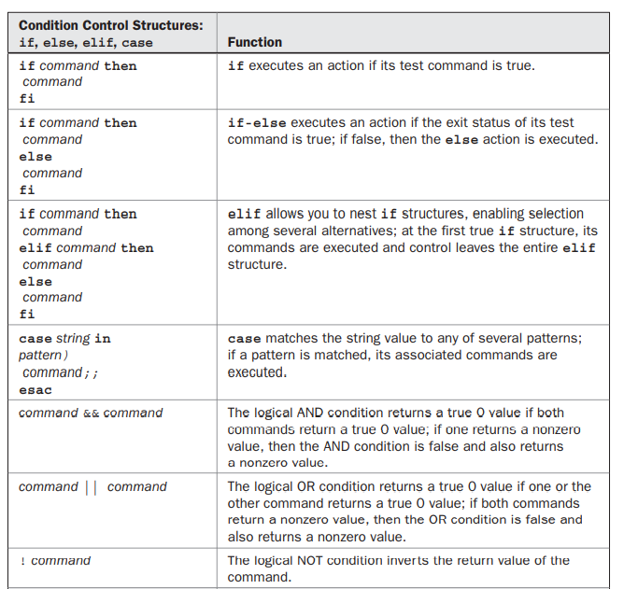

* + **PROCEDURE:**



* + **RESULTS** **AND CONCLUSIONS:**



1. **AIM: Write a program to illustrate the implementation of loop control structures**
   * **THEORY:**

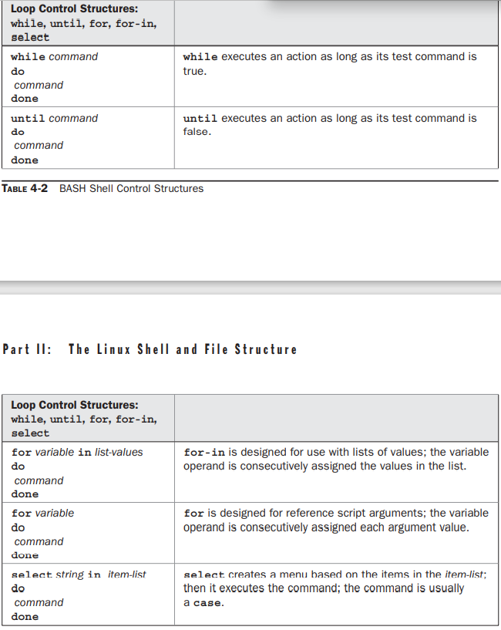

* + **PROCEDURE:**

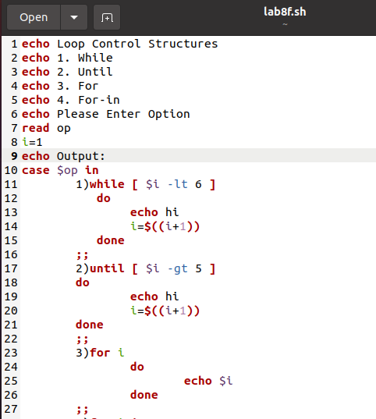

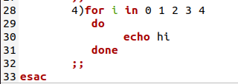

* + **RESULTS** **AND CONCLUSIONS:**

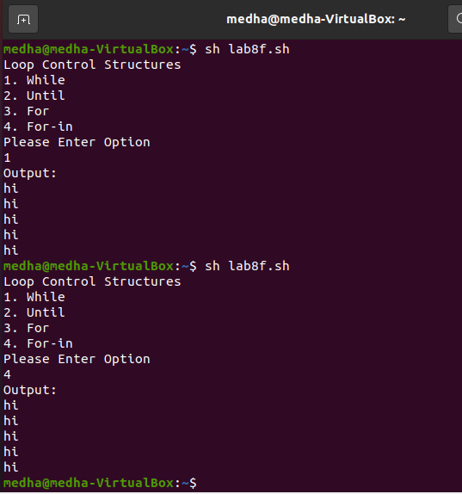

LAB 9

**AIM: Write a program for Simple Password Manager Application in Linux**

**THEORY:**

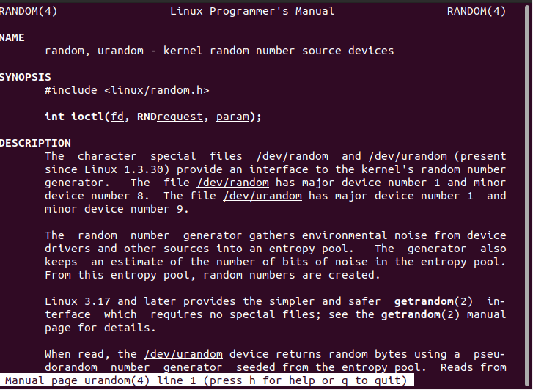

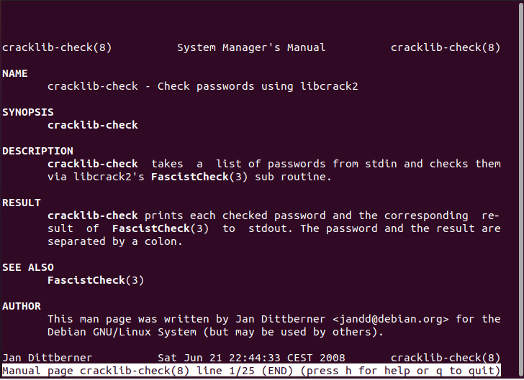

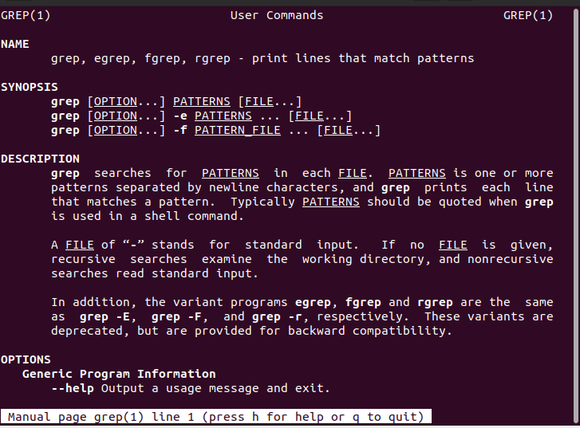

**PROCEDURE:**

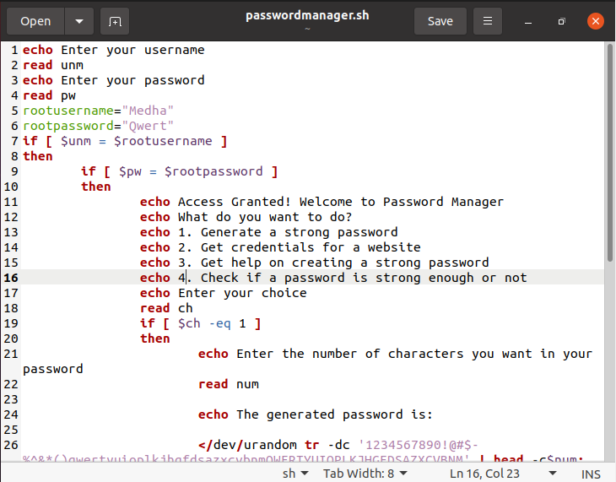

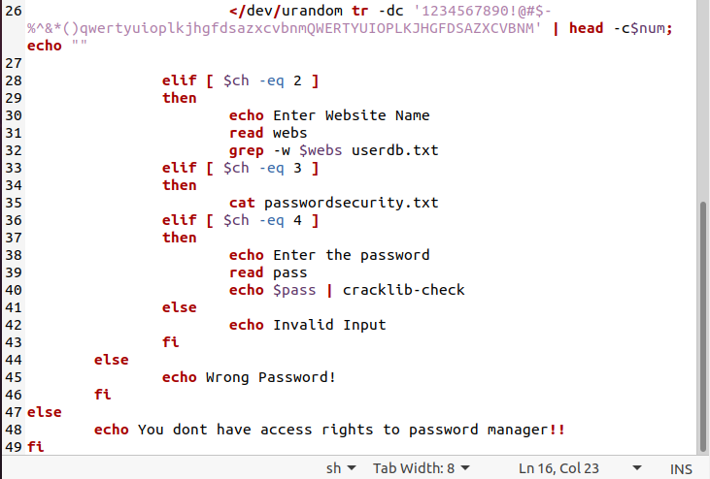

**RESULTS** **AND CONCLUSIONS:**

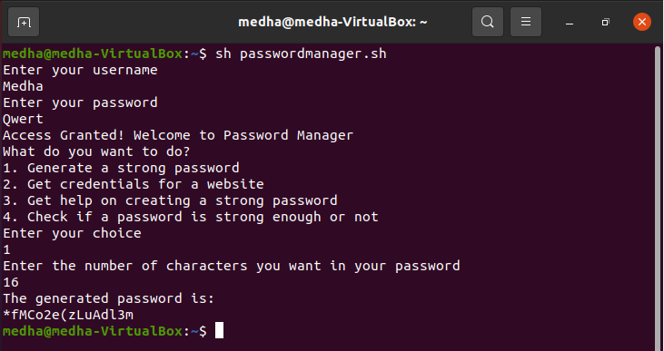

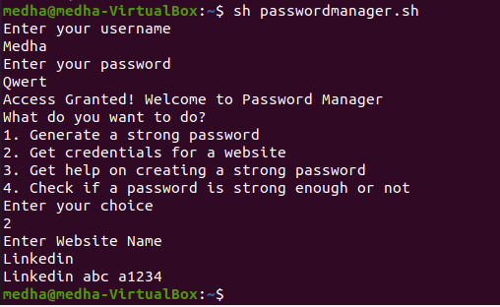

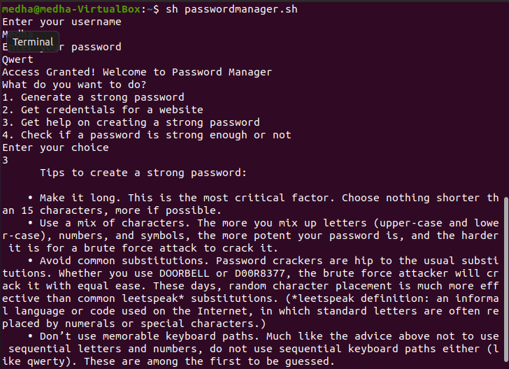

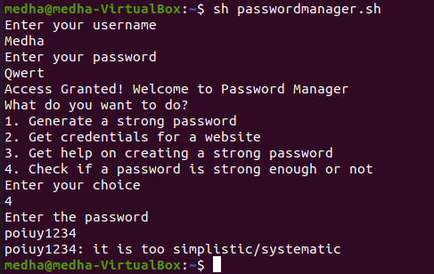

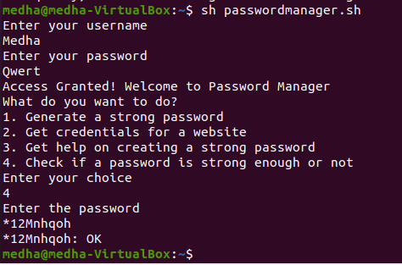

# LAB 10

1. **AIM: Write a shell script to print a number in reverse order**
   * **THEORY:**
     1. While loop runs till the condition provided in the [ ] is true
     2. % Operator is used to find the remainder
     3. / Operator is used to divide a number
   * **PROCEDURE:**

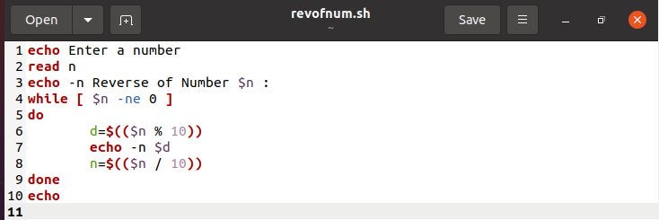

* + **RESULTS** **AND CONCLUSIONS:**

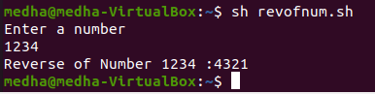

1. **AIM: Find the sum of all numbers in a file in Linux**
   * **THEORY:**
     1. **-**f command is used to check if a given file exists
     2. While read line do …. Done<$filename: reads the lines from the files one by one
   * **PROCEDURE:**

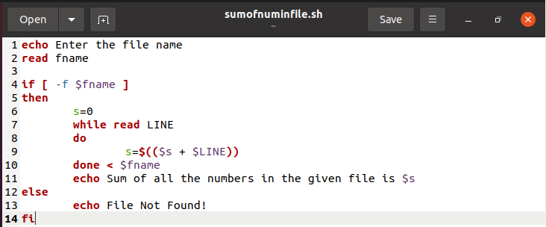

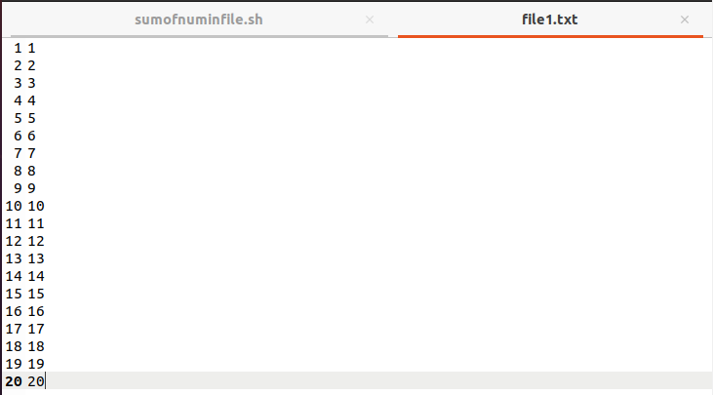

* + **RESULTS** **AND CONCLUSIONS:**

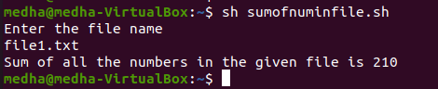

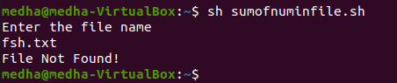

**C. AIM: Write a shell script to find out the unique words in a file and also count the occurrence of each of these words.**

**THEORY:**

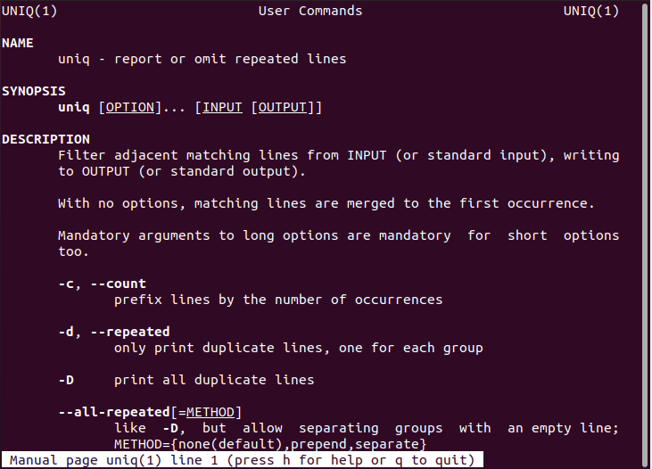

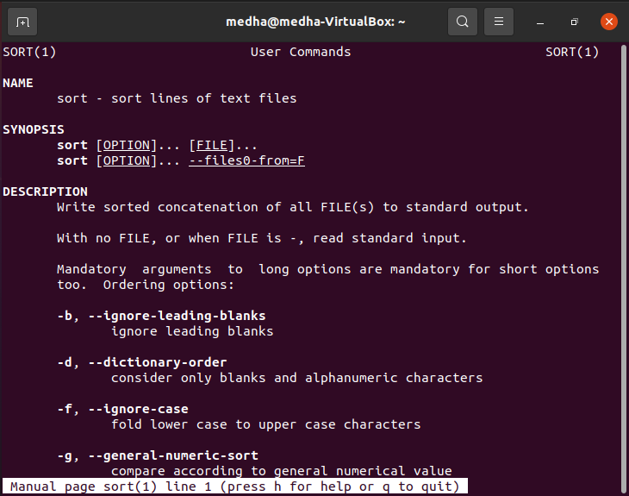

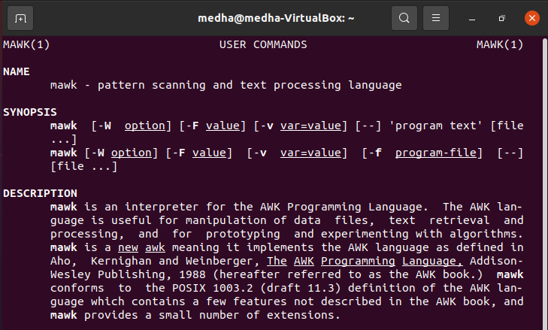

**PROCEDURE:**

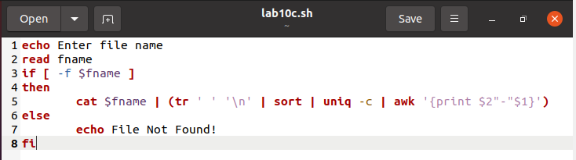

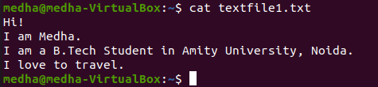

**RESULTS AND CONCLUSION:**

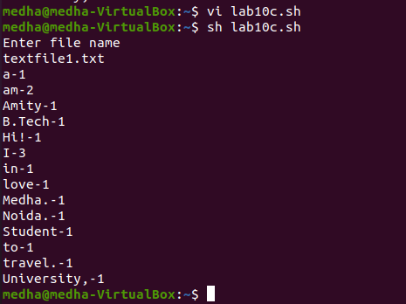

**D.AIM: Write a shell script to validate password strength. Here are a few assumptions for the password string. Length – minimum of 8 characters, contain both alphabet and number, Include both the small and capital case letters.**

**THEORY:**

**grep -q**

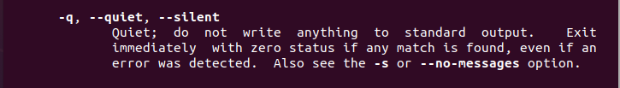

**PROCEDURE:**

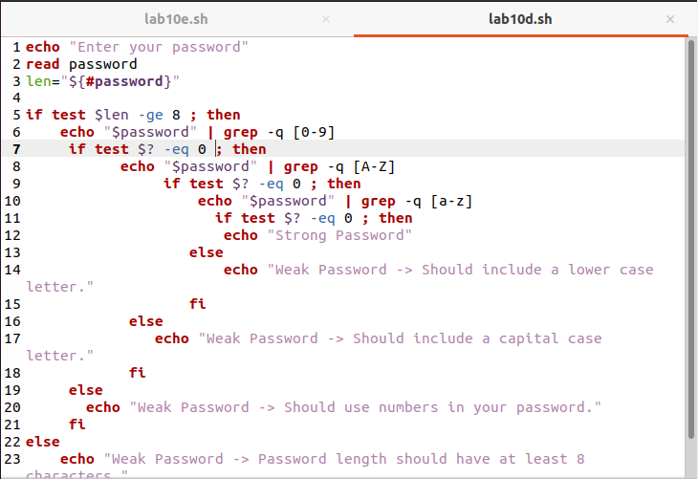

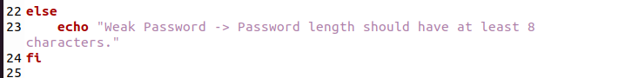

**RESULTS AND CONCLUSIONS:**

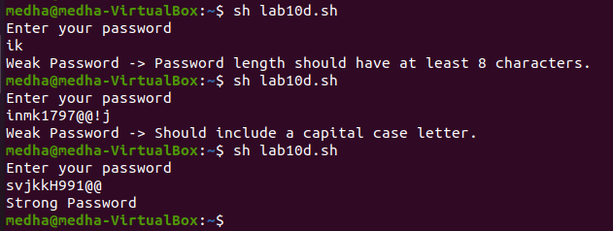

**E.AIM: Write a shell script to delete the lines containing a word <dd> if it appears between the 5th and 7th position?**

**THEORY:**

**sed -i**

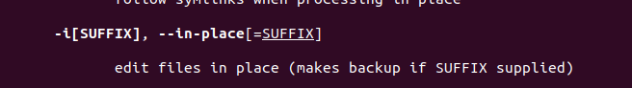

**PROCEDURE:**

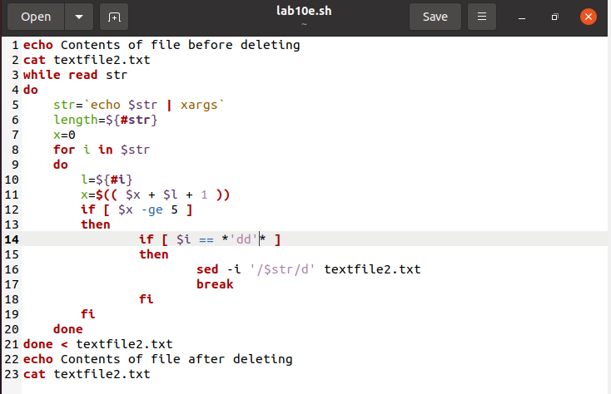

**F.AIM: Write a shell script to delete the lines containing a word <dd> if it appears between the 5th and 7th position?**

**THEORY:**

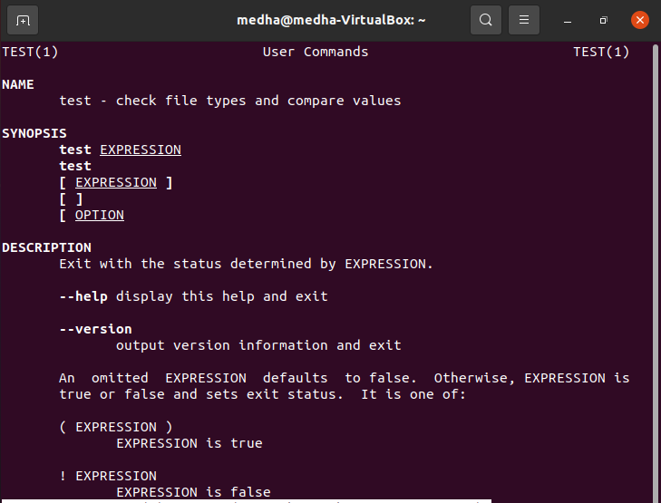

**PROCEDURE:**

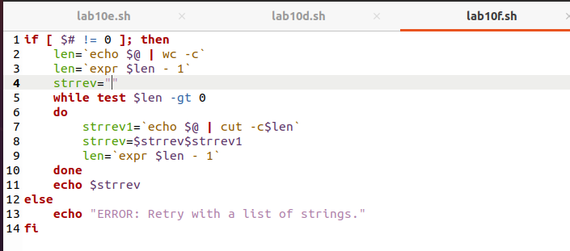

**RESULTS AND CONCLUSION:**

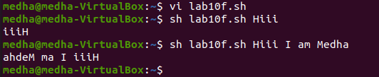

# LAB 11

**AIM:** Design and develop a “Birthday Reminder” that can automatically send birthday wishes with a personalized message via email.

**THEORY:**

* **How to store data in csv file in Linux?**
  + Open calc and save the file as .csv
  + Specify file and string delimiters
  + You can enter the data manually or through shell script now.
* **Read .csv file (e.g: file name is input.csv and fields are field1 and field2**

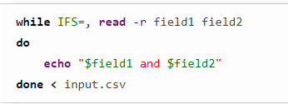

* **Get today’s date and month**

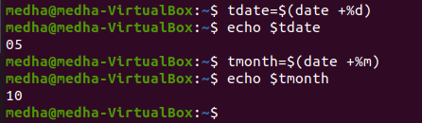

* **Man date**

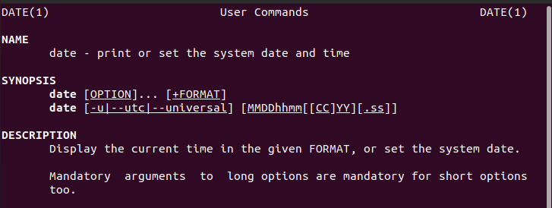

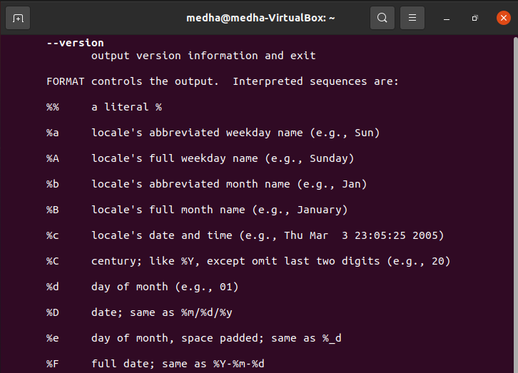

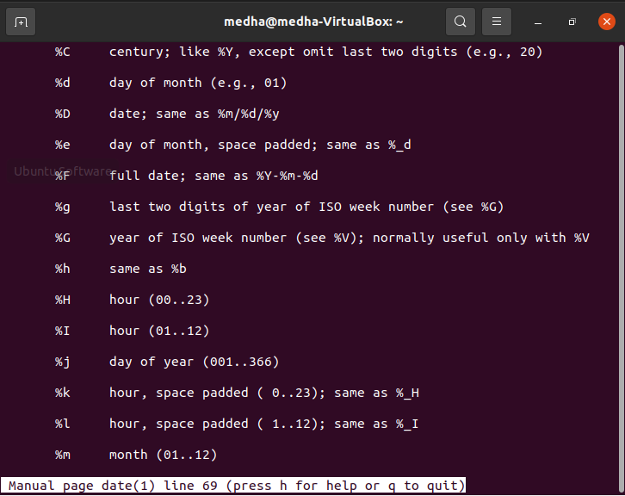

* **Man ssmtp**
* 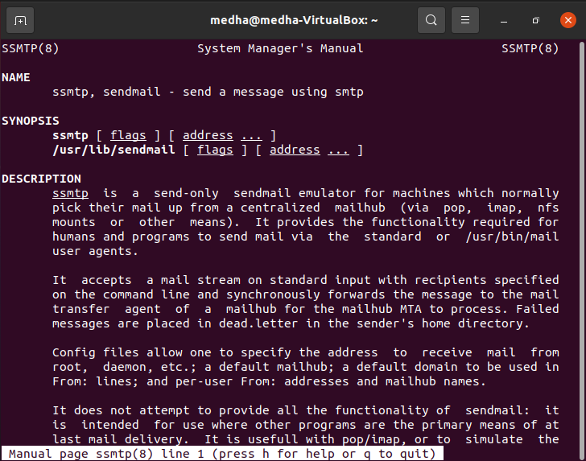
* **ssmtp <recipient_email_address> < <filename>** is used to send email to recipient_email_address and the contents of the email include contents of filename.

**PROCEDURE:**

**Part 1: Input Birthday Dates and store in CSV (Comma Seperated Value) file**

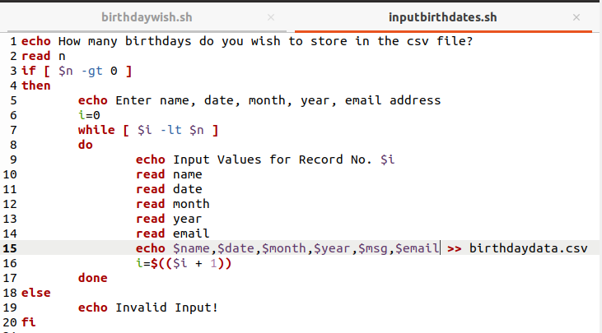

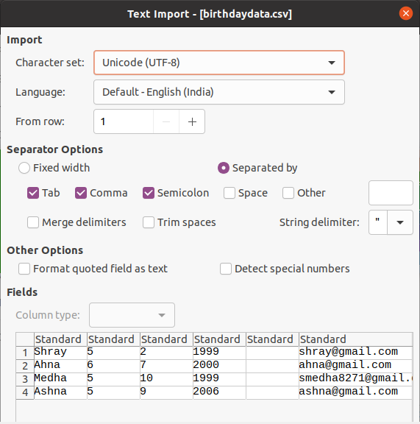

**Part 2: Setting up ssmtp**

Step 1: run the command sudo apt install ssmtp

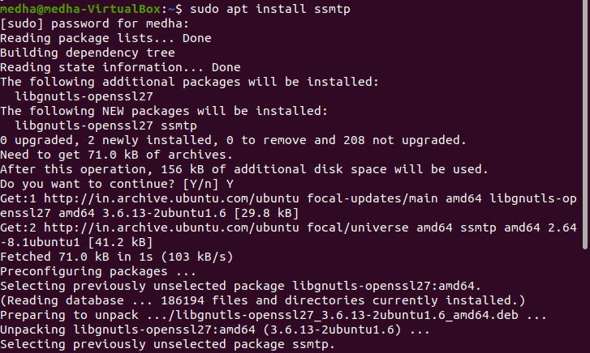

Step 2: Change permissions for /etc/ssmtp and cd to **/etc/ssmtp**

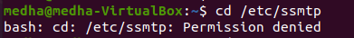

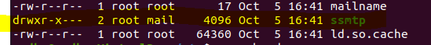

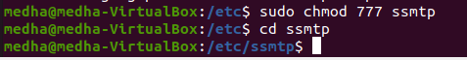

Step 3: Run **nano** **ssmtp.conf.** If the command does not work, use chmod command to change permissions for the file.

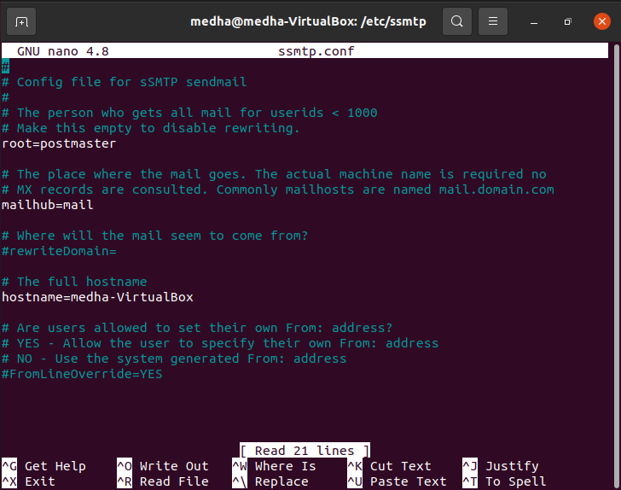

Step 4: Edit the ssmtp.conf file

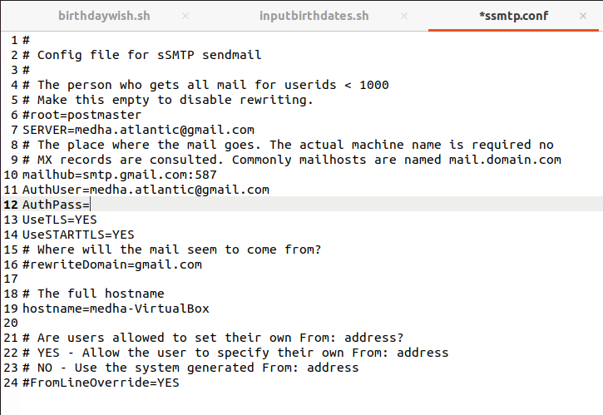

Step 5: Check if mail is sent



Step 5: Allow access to less secure apps, if authorization fails

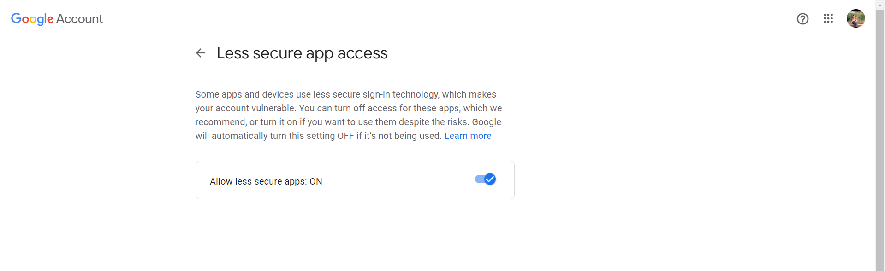

Step 6: try again





**Part 3: Write a shell script to wish Happy Birthday**

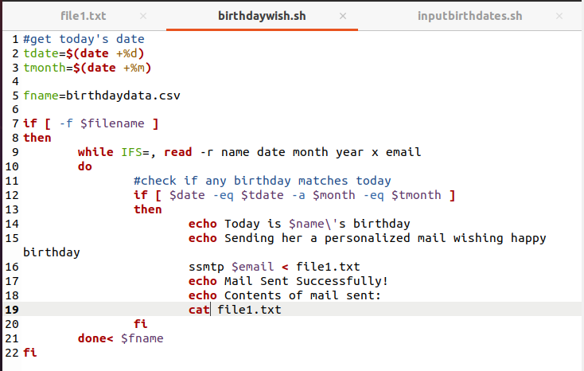

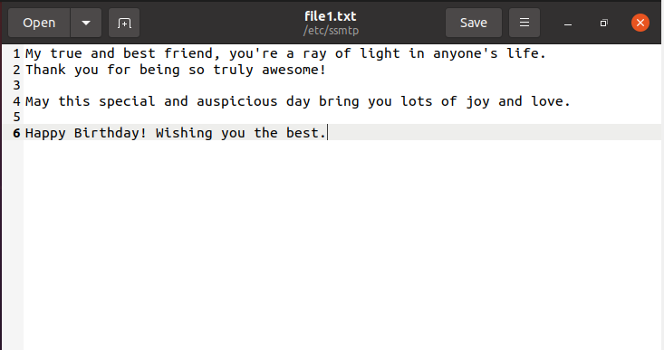

**RESULTS AND CONCLUSIONS:**

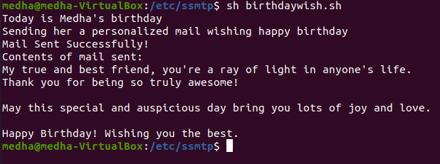



# LAB 12

**AIM**: **Implementation of NIC bonding and Team**

**THEORY:**

NIC Teaming uses one of two methods, failover, and load-balancing with fail over. With a team you do not get a single 2 GB connection (with two 1 GB NICs). You get two pipes that act as one, but merely are load balancing the traffic over each NIC, and each NIC acts as a failure over to the other.

NIC Bonding refers to create a bond or aggregation of two or more links into one in order to provide failover and redundancy to the network.

Nmtui provides a text user interface.

**PROCEDURE:**

Step 1: Click on Take Snapshot option.

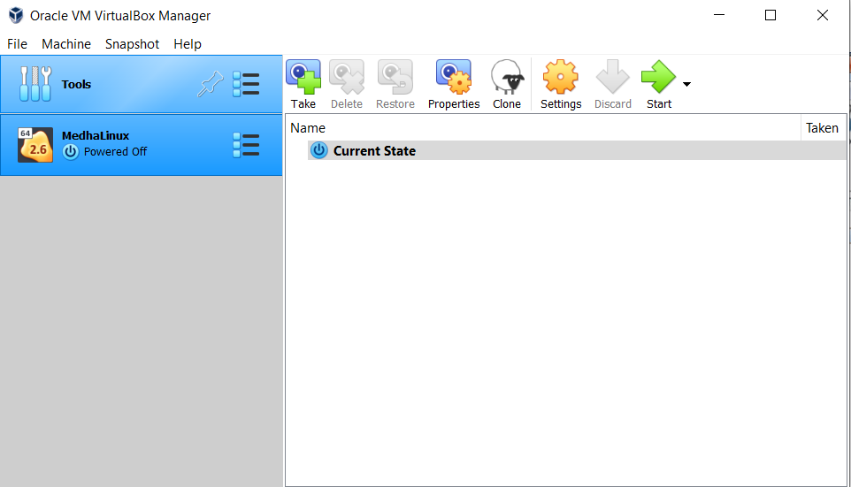

Step 2: Provide the snapshot name and click on OK.

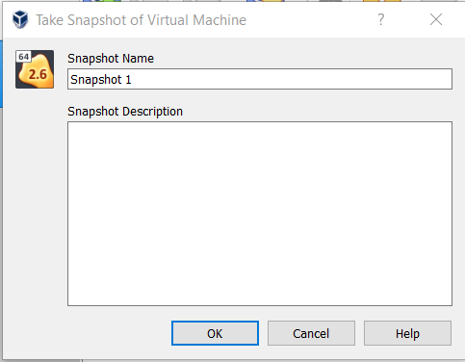

Step 3: The screen would now look like this.

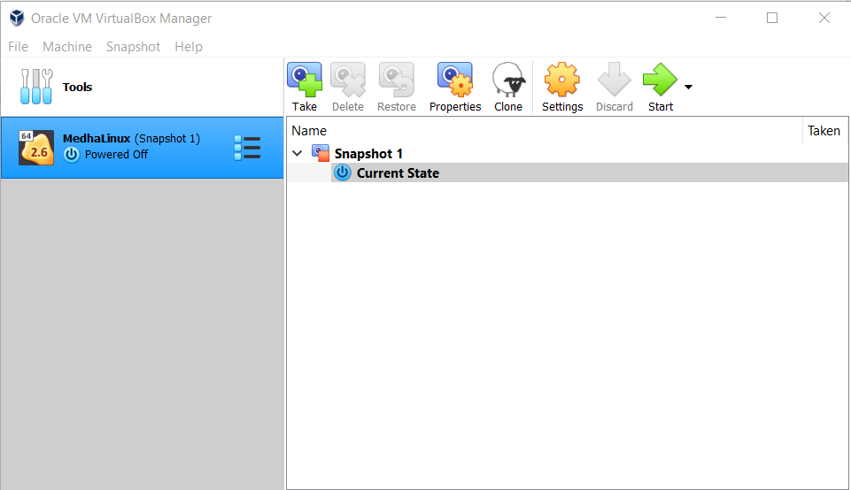

Step 4: Go to Settings > Network > Adapter 2

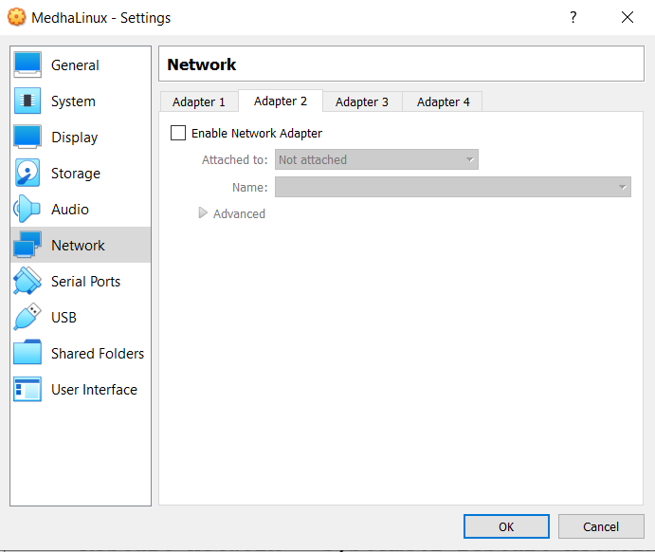

Step 5: Click on Enable Network Adapter.

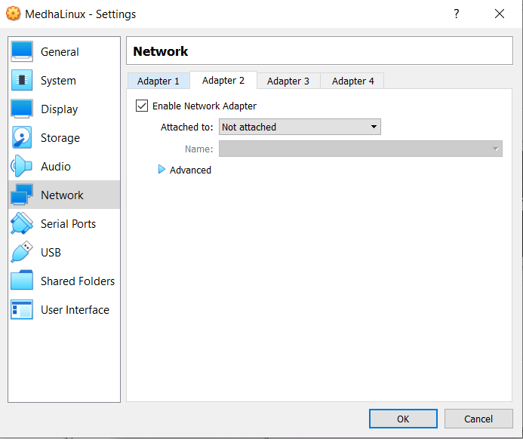

Step 6: Select Bridge Adapter and click on OK.

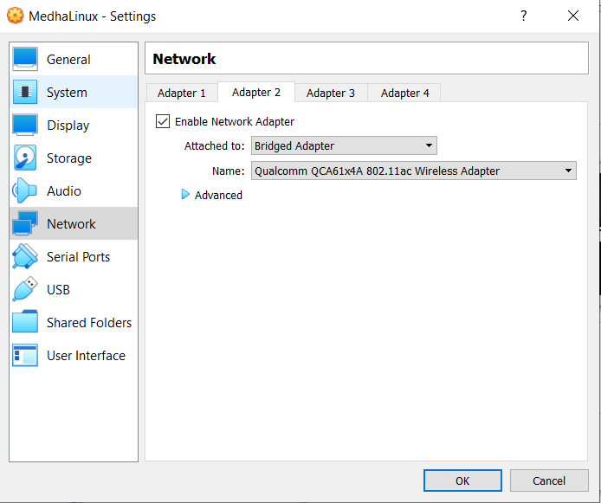

Step 7: The following window appears. Start the system.

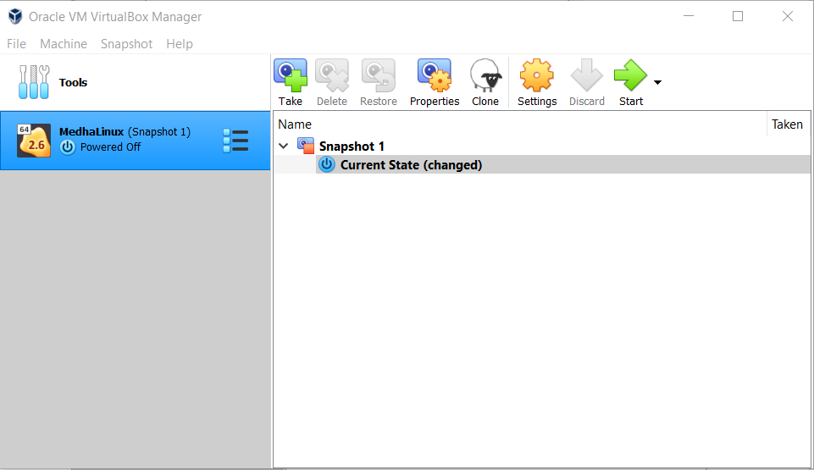

Step 8: Type in the command modinfo bonding

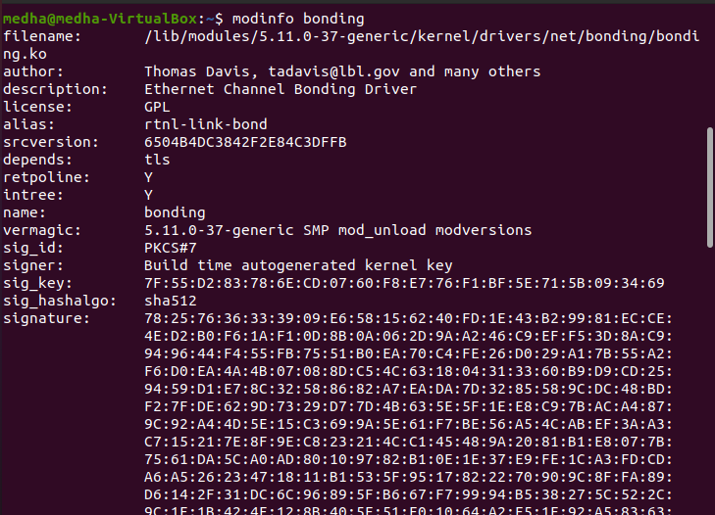

Step 9: Type in the command lsmod | grep bond & install ifenslave

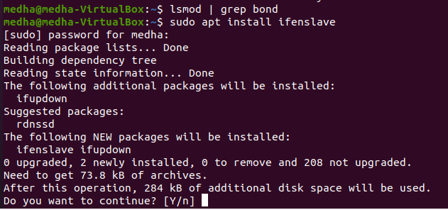

Step 10: Check how many interfaces are available for bonding

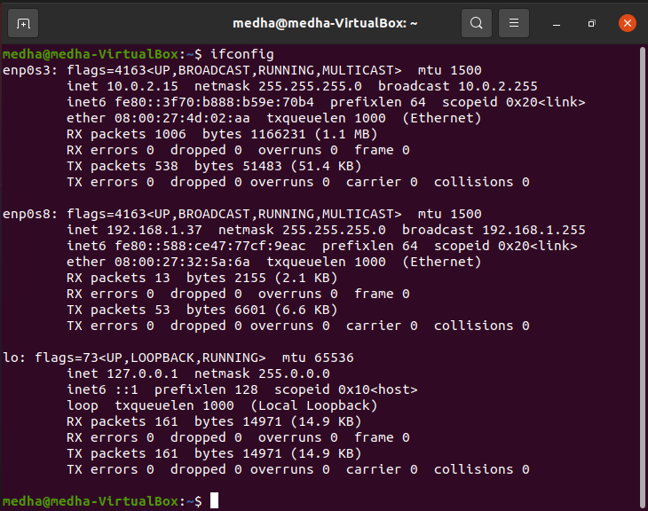

Step 11: Change the state of both the Ethernet interfaces to “down”

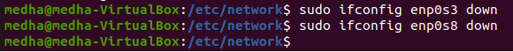

Step 12: make a bond network on master node bond0 via the ip link command, add both the interfaces to the master node and affirm the creation of network bonding

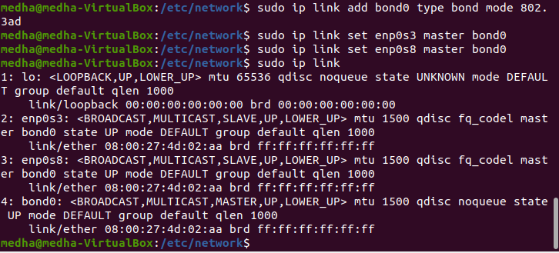

Step 13: Change permissions for /etc/network/interfaces file, update the configuration and save it.

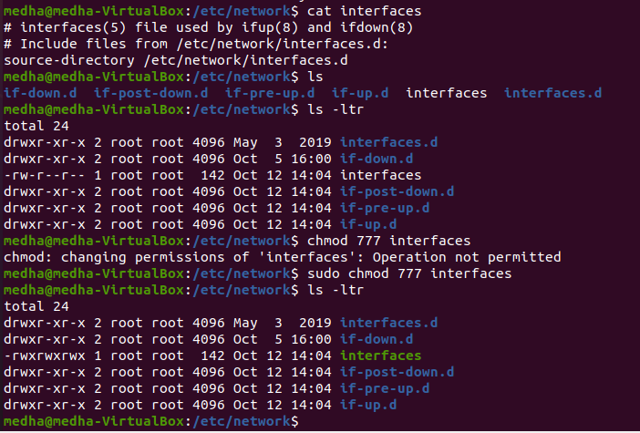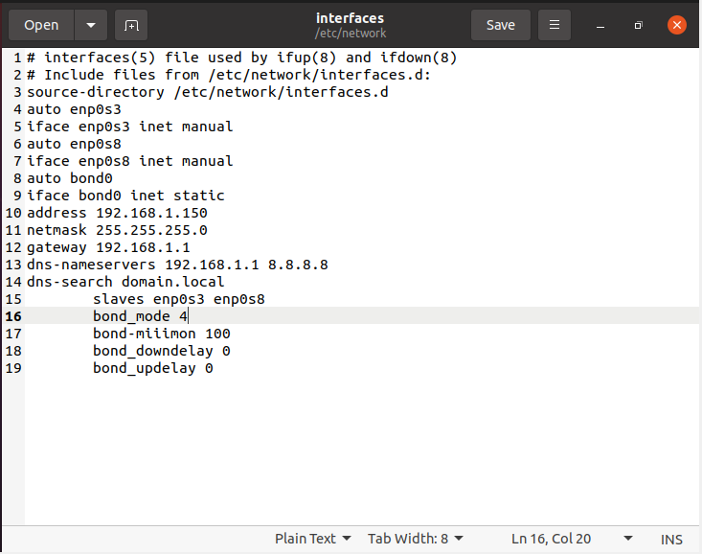

Step 14: To enable the network bond, we need to change the states of both slaves interfaces to down and change the state of the master node to up

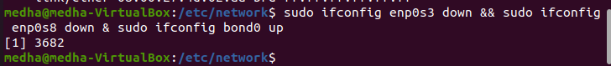

Step 15: restart the network service



Step 16: Confirm whether the master interface has been “up” or not

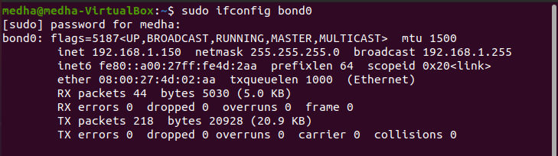

Step 17: Check out the status of a newly created network bond that has been created successfully by utilizing the below query.

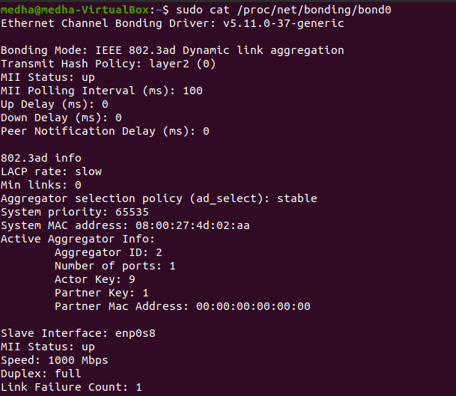

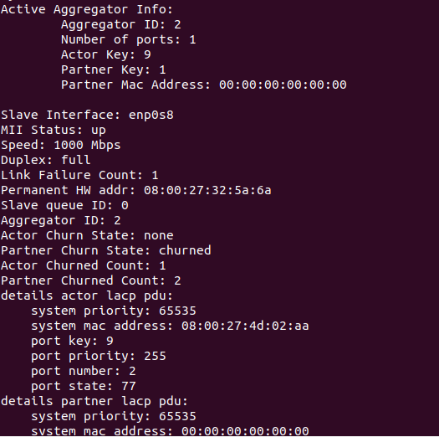

Step 18: Create a new machine

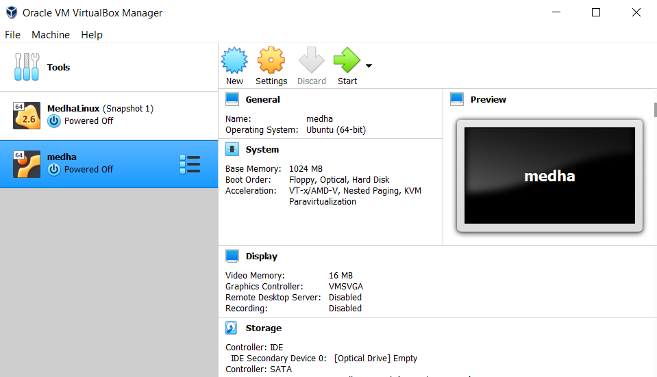

Step 19: Enable Network Adapter 2

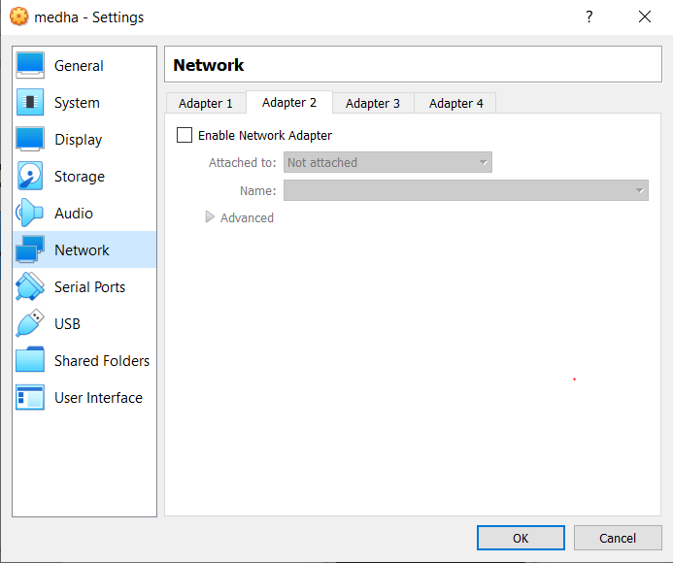

Step 20: Click on Bridged Adapter

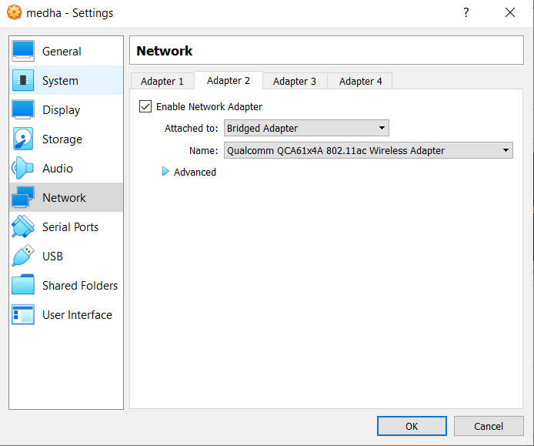

Step 21: Take Snapshot of current state

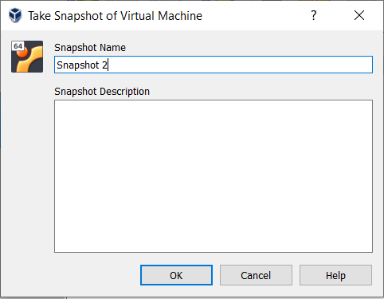

Step 22: The following screen appears

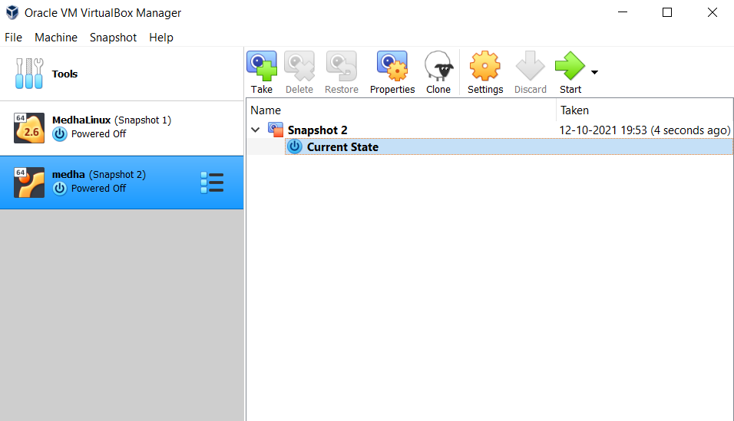

Step 23: Run the command ifconfig in terminal after starting the machine

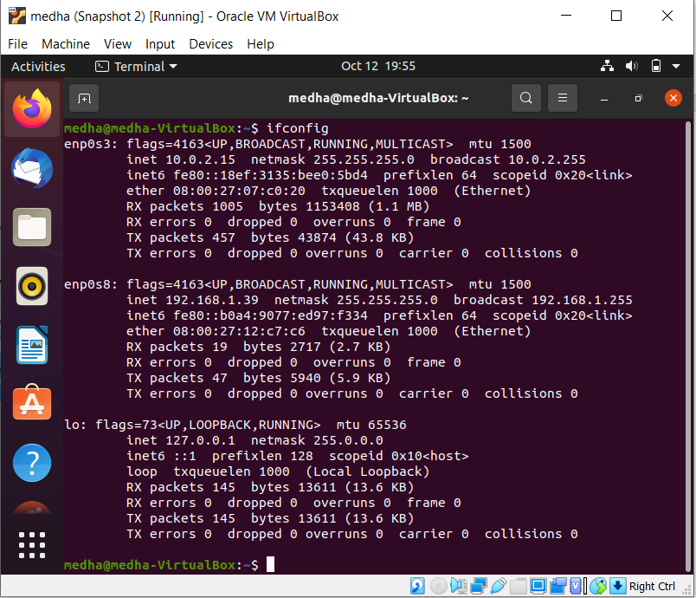

Step 24: Type in command nmtui.



Step 25: Click on Edit a connection

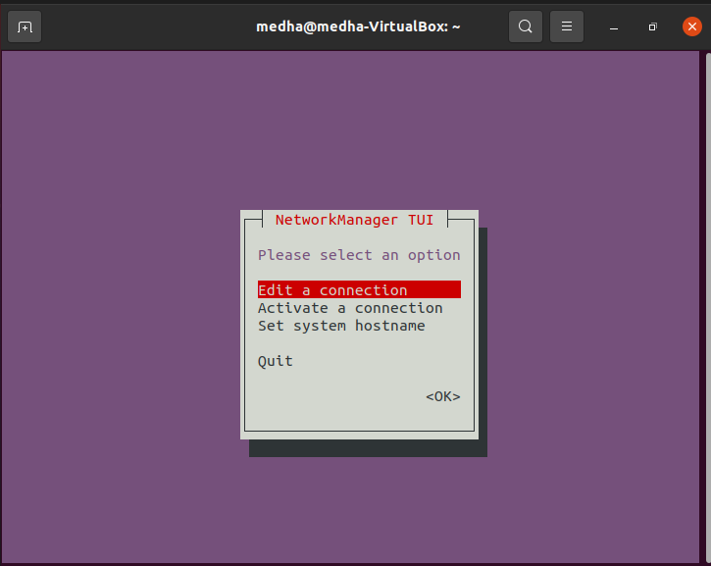

Step 26: Click on Wired connection 1

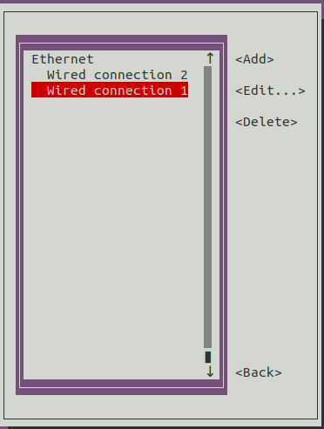

Step 27: Click on Delete.

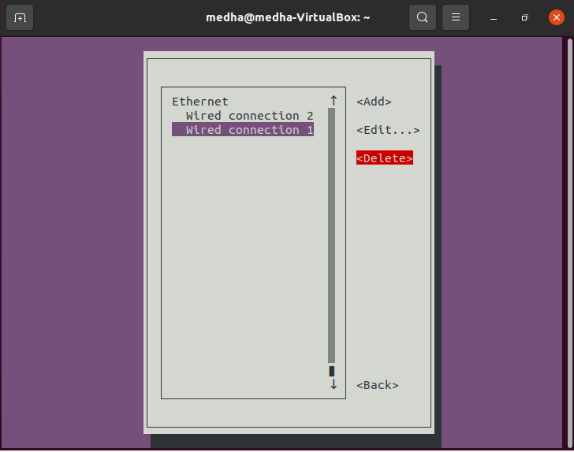

Step 28: Click on Delete.

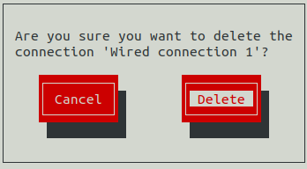

Step 29: Click on Back option

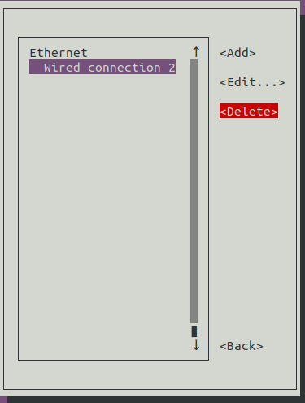

Step 30: Click on Quit.

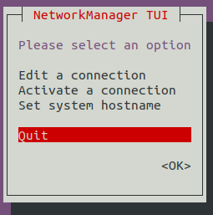

Step 31: Type in the following command: ifconfig | more

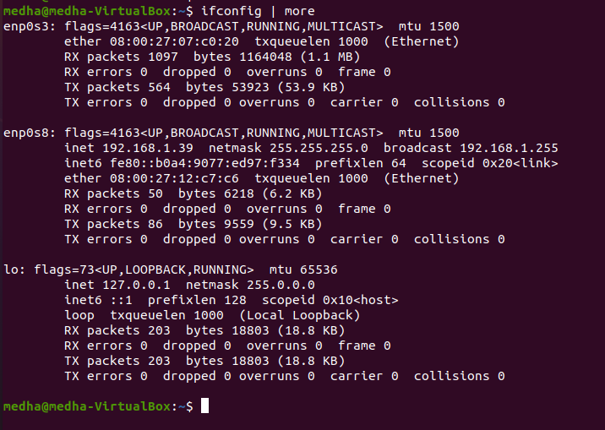

Step 32: Type in nmtui and then click on add and select team.

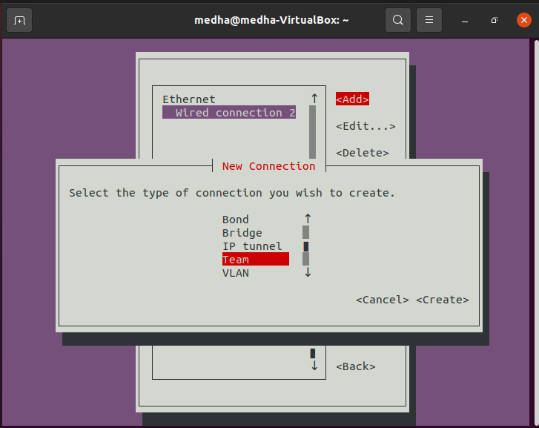

Step 33: Select the slave connection as Ethernet, add and edit the connection names.

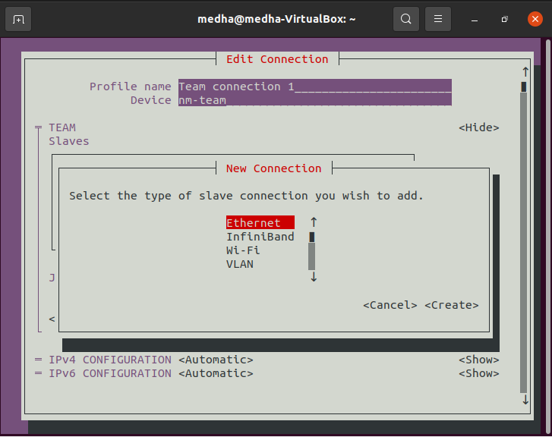

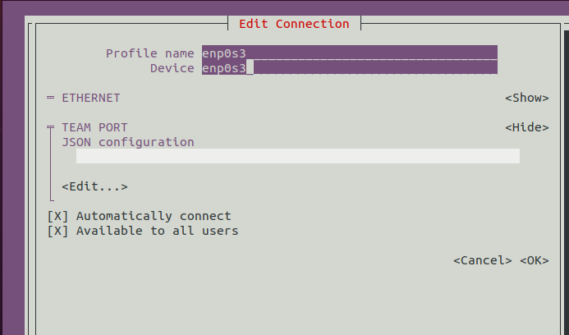

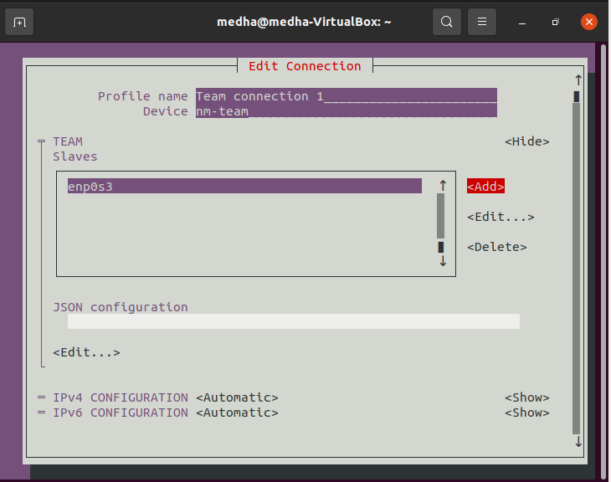

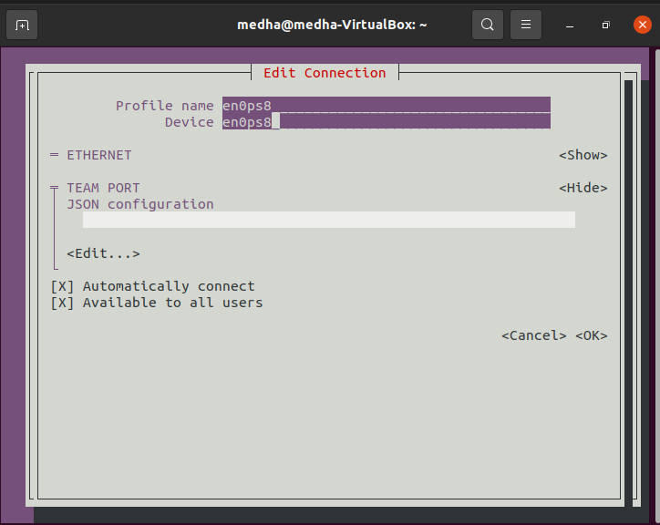

Step 34: Run the command: ifconfig | more , nmcli con show

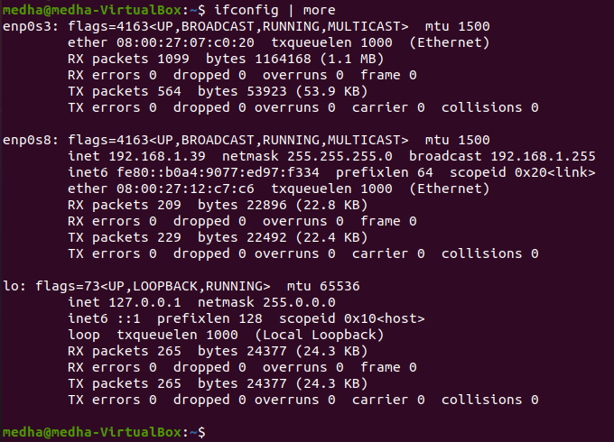

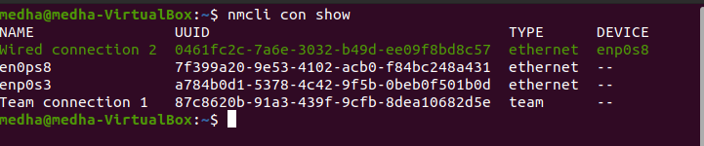

Step 35: Run the command nm-connection-editor in terminal

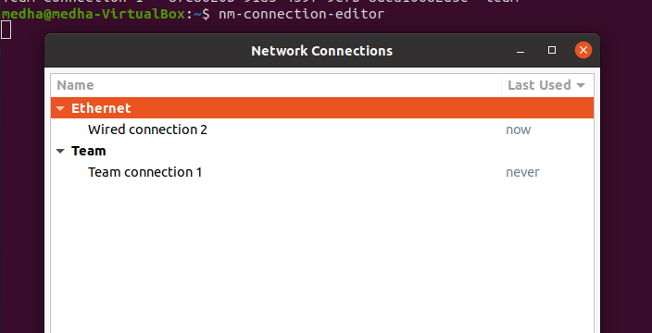

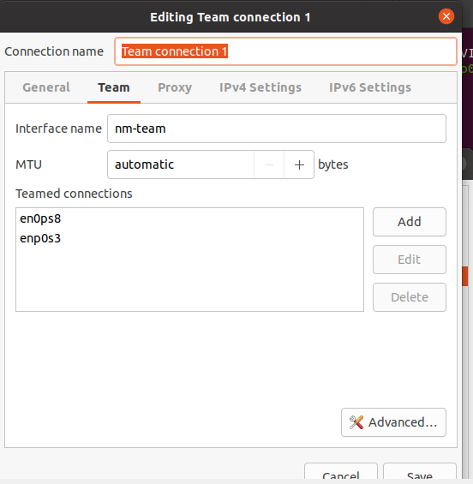

Step 36: Edit the interfaces file configure bond0 and make eth0 and eth1 as slave of bond0

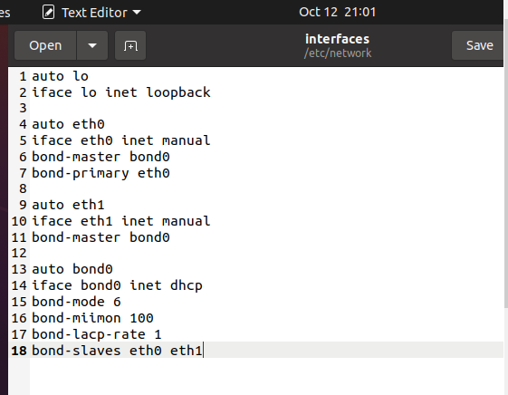

Step 37: Restart NetworkManager.service



Step 38: Run ifconfig command

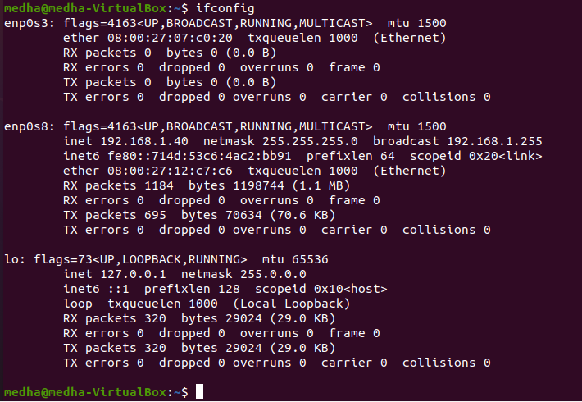

Step 39: Run the following command



**RESULTS AND CONCLUSIONS:** NIC Bonding and Teaming have been implemented.

# LAB 13

**AIM**: Configure NFS Server and Client in Linux

**THEORY:**

NFS, which stands for Network File System, is a distributed filesystem protocol that allows for the mounting of remote directories from an NFS server onto a client server. These directories can then be accessed from the client much like local storage, and the mounting process can even be automated for greater convenience. Using NFS mounts is a useful ability in situations where space usage needs to be optimized and multiple clients need to access the same server space, with the main advantage of NFS being its allowance for central management of files. This decreases administrator workload as well as enhancing the sharing possibilities of individual files and repositories.

NFS or Network File System was originally developed only by Sun Microsystems.

NFS operates in a client-server environment where the server is responsible for managing the authentication, authorization, and administration of clients, as well as for all data shared within a particular file system. After authorization, any number of clients can access the shared data as if it were in their internal storage.

Using NFS is quick and easy for accessing remote network systems, the protocol NFS uses is not encrypted and thus considerations should be taken such as routing over SSH or VPN in order to enhance security.

**PROCEDURE:**

**Part 1: Set up a server and client machine**

Step 1: Clone your virtual machine

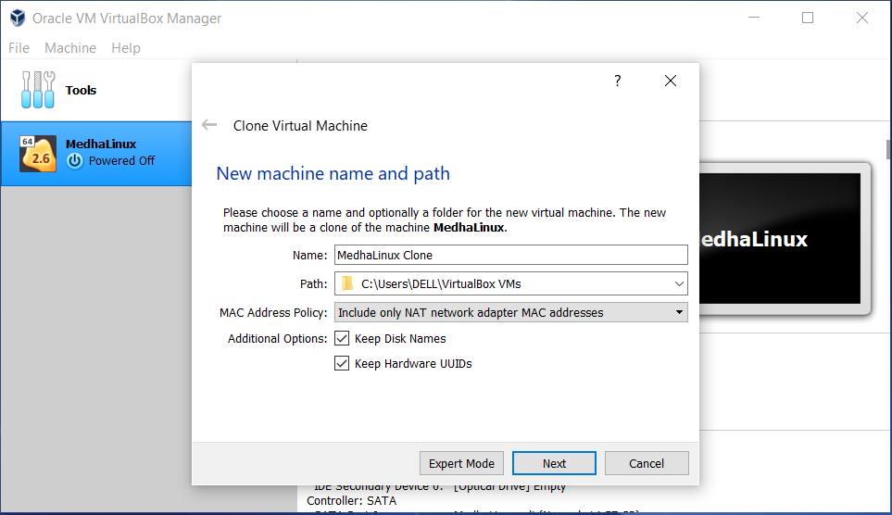

Step 2: Select the clone type as Linked Clone.

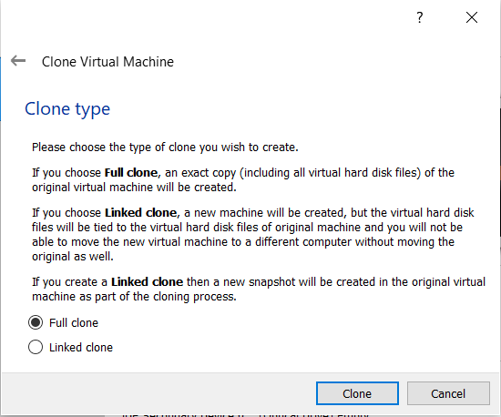

Step 3: Go to Network Settings. Click on attached to: host-only adapter.

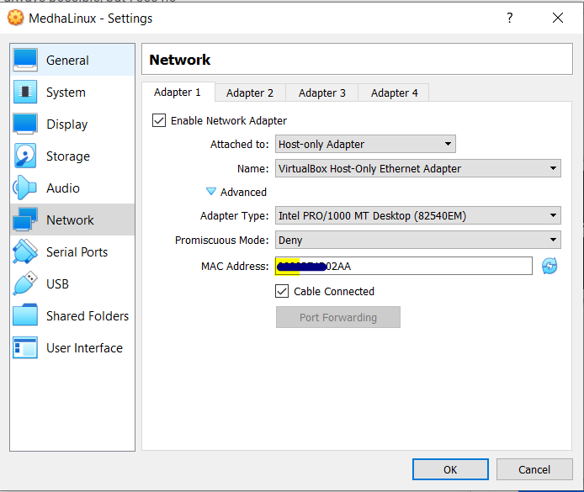

Step 4: Go to Network Settings. Click on attached to: host-only adapter and change the MAC address for this machine by clicking on Refresh option.

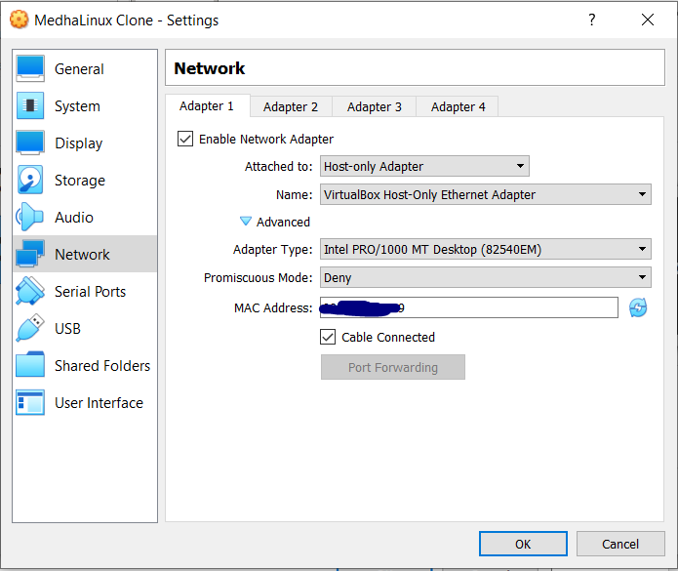

Step 5: Start both the machines and type in ‘ip a’ command on both system’s terminal.

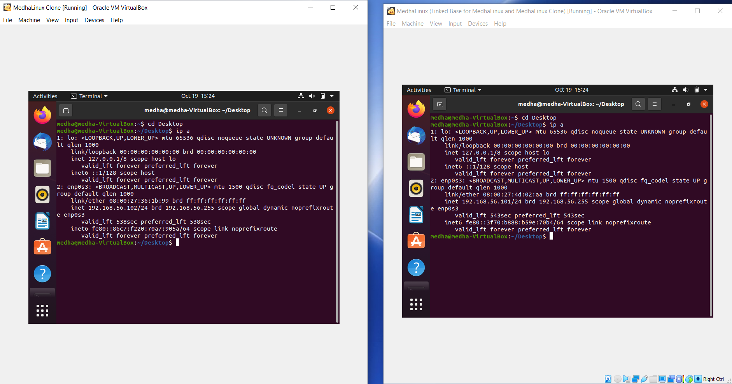

Step 6: Ping server machine from the client machine.

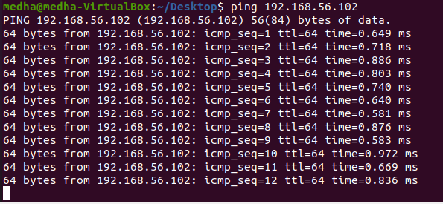

Step 7: Ping client machine from the server machine.

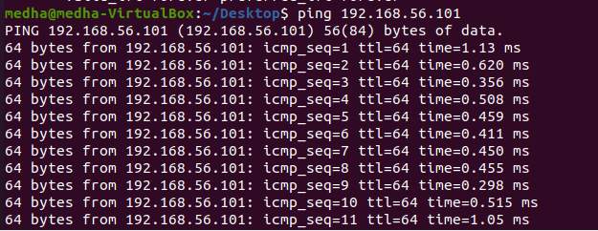

**Part 2: Setting up host server**

Step 1: Install NFS Kernel Server

1. Install the latest available version of a software through the Ubuntu repositories.

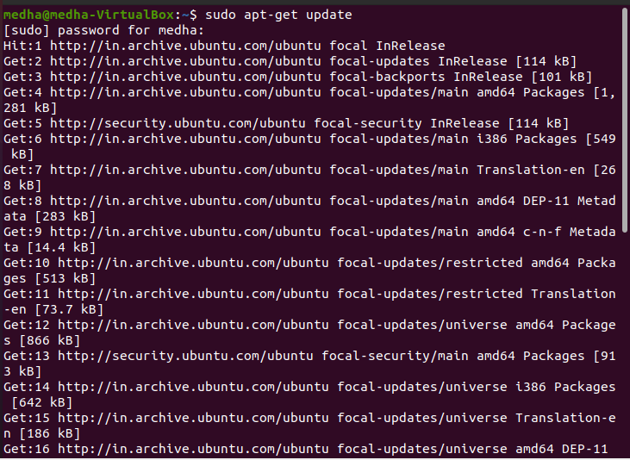

1. Install the NFS Kernel Server on your system

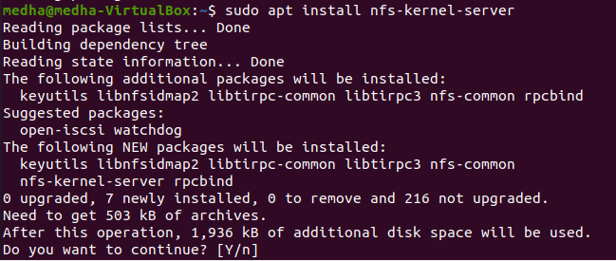

Step 2: Create Export Directory

The directory that we want to share with the client system is called an export directory. Make a directory and change its permissions.

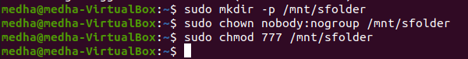

Step 3: Assign server access to client(s) through NFS export file

1. Type in sudo nano /etc/exports command in terminal.

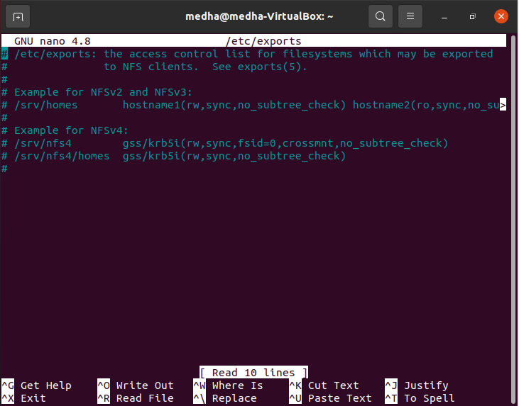

1. Multiple clients, by specifying an entire subnet that the clients belong to:

/mnt/sharedfolder subnetIP/24(rw,sync,no_subtree_check)

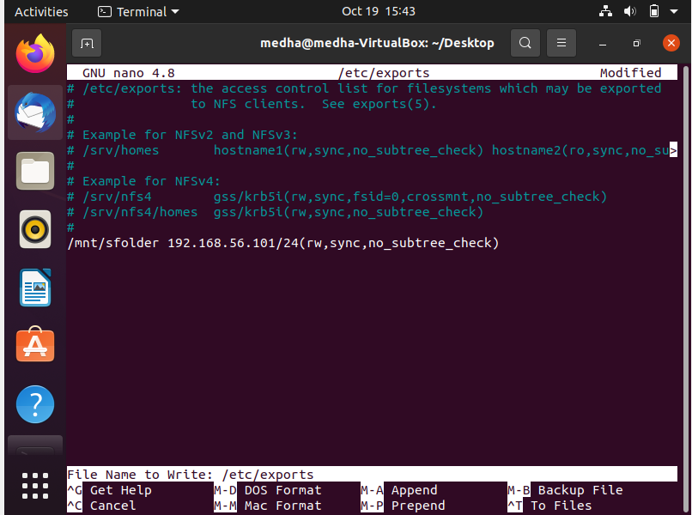

The permissions “rw,sync,no_subtree_check” permissions defined in this file mean that the client(s) can perform:

* + rw: read and write operations
  + sync: write any change to the disc before applying it
  + no_subtree_check: prevent subtree checking

Step 4: Export the shared directory

Export the shared directory and restart the NFS Kernel server.

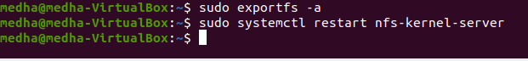

Step 5: Open firewall for the client (s)

1. An important step is to verify that the server’s firewall is open to the clients so that they can access the shared content.

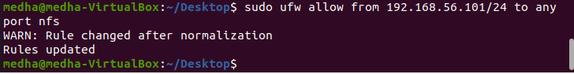

1. Check the status of your Ubuntu firewall.

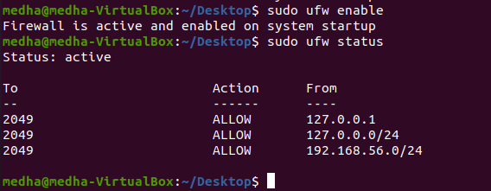

**Part 3: Configuring the Client Machine**

Step 1: Install NFS Common

Run the following command in order to install the NFS Common client on your system.

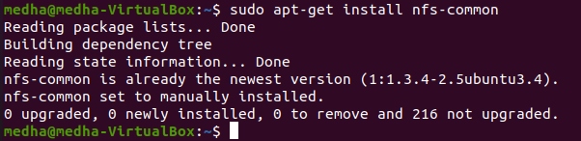

Step 2: Create a mount point for the NFS host’s shared folder and mount the shared directory on the client

Create a mount folder in the mnt directory of our client’s machine and mount the shared folder from the host to a mount folder on the client.

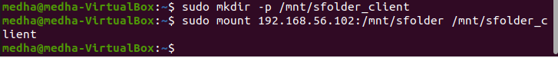

Step 3: Test the connection

1. Please create or save a file in the export folder of the NFS host server

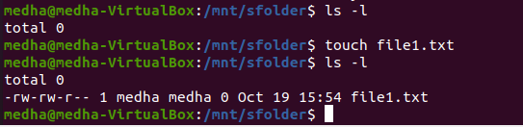

1. Open the mount folder on the client machine; you should be able to view the same file shared and accessible in this folder.

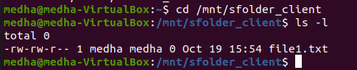

**RESULTS AND CONCLUSIONS:**

NFS Server and Client have been successfully configured.